Resort Village of Elk Ridge
Meeting Agenda
April 12th, 2022 at 3:00 p.m. – Regular Council Meeting -White Tail Room

- Call to Order – The Mayor called the meeting of Council to order.
- Delegations: Fire Chief Chris McShannock, Lakeland District Fire Department sends regrets for this meeting.
55-2022 SMITH-WINDSOR: That Council direct administration to send a letter to Lakeland District Fire Department requesting to enter into negotiations for Fire Service Agreement.
CARRIED
56-2022 ENGEL: That the negotiation committee consist of Garry McKay, Ryan Danberg and the CAO as the advisor. CARRIED
- Approval of Agenda:
57-2022 SMITH-WINDSOR: That the agenda for this meeting be approved as presented.
CARRIED
- Public Hearings: None
- Reading of Bylaws: None
- Adoption of Minutes:
6.1 Page 3– Minutes of the March 8th, 2022 meeting.
MOTION: That the Minutes of the March 8th, 2022 Meeting be approved as presented.
- Business Arising from Minutes: None
8. Action/Motion Items:
8.1 Page 6 – PARCS Membership
8.2 Page 8– RFP Website Design
8.3 Page 11– Board of Revision and Development Appeals Board
  - Page 18– UMAAS Convention
- Administration Reports:
9.1 Page 19- CAO Report and Updates
- Accounts for Payment:
- Financial Statements:
  - Page 20– Financial Statement for March, Bank Reconciliation and List of Accounts
MOTION: That Council receive and file the financial statement, bank reconciliation and list of accounts payable for March, 2022.
Note: The bank reconciliation was not available at the production of this agenda and will be provided prior to the meeting.
- Council Divisional Reports: N/A
- New Business: N/A
- Incamera: N/A
- Correspondence:
15.1 Page 25 - SAMA AGM Invitation
- Other Business:
- Adjournment
Resort Village of Elk Ridge
Meeting Minutes
March 8th, 2022 Regular Meeting of Council

A Regular Meeting of Council of the Resort Village of Elk Ridge was held at the Elk Ridge Golf Resort on March 8th, 2022.

Present: Mayor Garry McKay
Councillor Ryan Danberg
Councillor Trudy Engel
Councillor Ross Hewett (via teams meeting)
Councillor Margaret Smith-Windsor

Heather Scott, CAO (via teams meeting)

- Call to Order – With a quorum being present, Mayor Garry McKay called the meeting to order at 3:00 p.m.

- Delegations: None

- Approval of Agenda:
47-2022 SMITH-WINDSOR:
That the agenda for this meeting be approved as presented. CARRIED
- Public Hearings: None
- Reading of Bylaws: None

- Adoption of Minutes:
6.1 Minutes of the February 8, 2022 Council Meeting.
48-2022 HEWETT:
That the Minutes of the February 8th, 2022 Council Meeting be approved as presented.
CARRIED

- Business Arising from Minutes:
7.1 – Letter received March 3rd, 2022 from North Central Waste Management Corporation.

49-2022 ENGEL:
That Council receive and file the letter dated March 3rd, 2022 from the North Central Water Waste Management Corporation. CARRIED

50-2022 ENGEL:
That Council appoint Councilor Margaret Smith-Windsor to represent the Resort Village of Elk Ridge on that Committee, if required. CARRIED
- Action/Motion Items:
  - Municipal Revenue Sharing.
51-2022 SMITH-WINDSOR:
The Council of the Resort Village of Elk Ridge confirms the municipality now meets the following eligibility requirements to receive the Municipal Revenue Sharing Grant, including:
- Submission of the 2021 Audited Financial Statement to the Ministry of Government Relations;
- It is not applicable for the Resort Village of Elk Ridge Public a Report on Municipal Waterworks to the Ministry of Government Relations;
- In Good Standing with respect to the reporting and remittance of Education Property Taxes;
- Adoption of a Council Procedures Bylaw;
- Adoption of an Employee Code of Conduct;
- All members of council have filed and annually updated their Public Disclosure Statements, as required; and
That we authorize the administrator to send a letter to the Ministry of Government Relations acknowledging the municipality now meets all eligibility requirements to receive their Municipal Revenue Sharing Grant.
CARRIED
- Administration Reports:
  - CAO Report and Updates-
  - ENGEL:
That Council receive and file the CAO report for February, 2022. CARRIED
- Accounts for Payment: N/A
- Financial Statements:
11.1 Financial Statement for February, Bank Reconciliation and List of Accounts
53-2022 HEWETT:
That Council receive and file the financial statement, bank reconciliation and list of accounts payable for February, 2022. CARRIED
- Council Divisional Reports: N/A
- New Business
- Incamera: N/A
- Correspondence:
- Other Business:
- Adjournment:
54-2022 DANBERG: That the meeting adjourn 3:50 p.m. CARRIED

Approved on April 12, 2022.

_____________________________ ___________________________
Mayor CAO

DECISION ITEM

Subject | PARCS Membership
Council Meeting Date Presented: | April 1, 2022
Agenda Item: | 8.1
Prepared By: | Heather Scott CAO

BACKGROUND:

- PARCS stands for the Provincial Association of Resort Communities of Saskatchewan. Their Goals is to engage resort communities in Saskatchewan in dialogue regarding issues that impact them including economic, environmental and social issues, lobby for Saskatchewan resort communities and foster increased capacity for resort communities to effectively govern and manage themselves.
- PARCS members include: Resort Villages, Organized Hamlets that are cottage communities, RM’s with cottage communities, cottage owner associations and individual members wishing to keep in touch with PARCS members.
- There are different types of membership:
- FULL MEMBERS are communities that pay fees based on the number of occupied sites in the community. FULL MEMBERS are entitled to:
- Receive all newsletters and email alerts
- Attend PARCS Conventions at reduced rates
- Vote at the PARCS Annual General Meeting
- Hold an office on the PARCS Board of Directors.
- ASSOCIATE MEMBERS are communities that pay $100 per year. ASSOCIATE MEMBERS are entitled to:
- Receive all newsletters and email alerts
- Attend PARCS Conventions at reduced rates
- PARCS holds their annual convention in Saskatoon in October each year. This year their convention will be October 19, 2022.
BUDGET & OTHER CONSIDERATIONS:
- $100 annual membership fee;
- Conference fees if attending.

RECOMMENDATION:
- That Council approve for membership to the Provincial Association of Resort Communities of Saskatchewan.
- That Council members consider attending the annual convention at a later date when more information is available.
PROPOSED MOTION:
- That Council approve for membership to the Provincial Association of Resort Communities of Saskatchewan.

Respectfully Submitted by: Heather Scott, CAO

DECISION ITEM

Subject | RFP Website Design
Council Meeting Date Presented: | March 30, 2022
Agenda Item: | 8.2
Prepared By: | Heather Scott CAO

BACKGROUND:
- Council has directed administration to explore the implementation of a website to improve communication to their ratepayers and visitors to the community.
- Accordingly, administration prepared an RFP for website design services and reached out to a dozen local website design companies.
- The deadline for submissions was March 28, 2022.
- Two submissions were received:
Name of Company | Overview | Cost
M.R. Websites | Based out of North Battleford  Over 20 years in business  - A Mobile, and Desktop browser-friendly website  - Expandable and upgrade-able features / systems  - Search engine optimization (considered from the ground up)  - Google Analytics installation  - URL redirect system for non-SSL server requests  - Initial content integration (to be provided by the municipality)  - Training on the use of management systems  - A new custom favorites icon for various devices  - Regular security checks, server maintenance, and backups  Other Options:  - Logo design - $170  - Contact form with mandril and recaptcha - $187  - Slideshow management feature - $408  - Standard Events Calendar management feature - $451  - Alert Banners - $330 | $2411 Website Design  $3957 Website Design Including all options
Lesia Payne | Square Space Software  Project Management and Planning  Meetings & communications - primary methods will be video calls, email, phone, and PM software  $360  UX Design - Information Architecture & SEO Consulting  [User Experience Design Consulting] Information Architecture / Site Structure Consulting &  Assessment (after SEO & based on Keyword research) for up to 10 (Page total is including Home &  Contact Us)  $240  Visual Design Style for your Brand  Creating a visual "Style Guide" that sets the precedent for your entire website design and creates a  standard visual 'language' for all of your pages.  $240  Web Development  Basic customized CSS work included where necessary AND inserting content for up to 10 content  pages (including the homepage). We will lay out each page in a beautiful, clean, and customized  fashion based on content. Includes (optional) set up of Mailchimp automatic updates/newsletter.  $2,000  Image processing and sourcing  Includes processing (possibly minor editing if needed) and reducing file size for each image on the  website. Approximately 2-3 images or icons/graphics will likely be needed per page. Includes basic  help sourcing images (free or stock photography). Stock photography costs are not included.  $120  Website Training (Basic)  2 hour training session (video) with the client on how to update new template  $240  Full Search Engine Optimization Package PLUS 1 report post-launch  Including- Keyword Research- Content Marketing Suggestions- Content Template document creation-  Page Title writing- Page Description writing- Page URL writing- On-Page SEO- Directory Submissionsincludes  1 ROI report  $950  Professional Copywriting Writing for SEO (Search Engine Optimization)  Professional copywriting for up to 10 key pages by writer Harrison Crerar at approximately 500 words  per page. Includes 1 initial client meeting (virtual).$800  Other Options:  UserLike integration and configuration  Integration of the UserLike chat widget, and initial configuration, as well as assistance setting up  automated responses, templates, etc.  This is a premium widget which includes a service fee; however, UserLike has a free starter package  that includes all core items. More information can be found on their site: https://www.userlike.com/  en/features  $360  accessiBe  Installation of a third party software solution that automatically scans your website daily for web  compliance and accessibility issues that may prevent user's with disabilities from accessing your site.  The subscription is purchased directly by the client, through the Lesia Design & Digital partner  account. Subscriptions are typically $49 if billed monthly, or $490 if billed yearly. | $4950 Website design and building

BUDGET & OTHER CONSIDERATIONS:
- Between $2500 – 4950 depending on which option Council chooses with ongoing annual licensing and monitoring fees dependant on which option Council prefers.
RECOMMENDATION:
- Based on the quotes received, administration recommends M.R. Websites with the options for a cost of $3957.
PROPOSED MOTION:

1. That Council approve the proposal of M. R. Websites for Website and Logo design services.

Respectfully Submitted by: Heather Scott, CAO

DECISION ITEM

Subject | Board of Revision and Development Appeals
Council Meeting Date Presented: | March 23, 2022
Agenda Item: | 8.3
Prepared By: | Heather Scott CAO

BACKGROUND:
- Under the Minister’s Order, the District of Lakeland bylaws pertain to the Resort Village of Elk Ridge for a set period of time or until they are replaced by the Resort Village of Elk Ridge.
- Under Bylaw 6-2007 and revised in 2013 several communities formed part of a District Board of Revision. This Board heard any Assessment Appeals as well as shared the cost of a Board Secretary each year. The communities included in this agreement were: The District of Lakeland, the RM of Paddockwood, the Resort Village of Candle Lake and the RM of Garden River.
- Under the bylaw, the costs for the Secretary were: .$15/hr, 52/km travel plus any out-of-pocket expenses.
- Board members were paid $120 for a full day hearing (in excess of 4 hours), $60.00 per half day hearing (less than 4 hours), Travel $.52/hm and $15/hr/appeal prep time up to a maximum of 2 hours per appeal. Each community had a person on the board.
- There was also a food allowance of $20 per person for lunch.
- When looking into this for the Resort Village of Elk Ridge 2022 assessment appeals, it was discovered that many of these communities are now outsourcing these appeals to a third party. The District of Lakeland and the RM of Paddockwood are both using a company named Western Municipal Consulting.
- There are not a lot of other companies currently that provide similar services.
- Administration reached out to Western Municipal Consulting located out of Meota and requested quote for services. It was discovered that they also provide Development Appeal Services. Their fee breakdown is as follows:
- WMC Retainership Fee: $250.00 per calendar year or portion thereof. Due on Jan 31 each year or thirty (30) days after signing a new Service Agreement.
- WMC Hourly Staff Rate: $50.00/hr
- WMC Staff Mileage for Appeal Hearing Travel: $0.60/km
- WMC Printing fee for Notifications, Board Member Packages, Decisions, and Transcripts: $0.15/page
- Board Member Rate: $75.00/hr per Board Member
- Board Member Mileage: $0.60/km
- Postage: Standard Canada Post Rates
- Facility Rental: As dictated by appeal venue.
- A board of revision is required to be in place prior to issuing assessment notices.
- There is similarly a 30 day window in which to schedule a Development Appeal in the event the municipality is to receive one.
- There was one more company identified as performing this type of service in the province. Administration had difficulty finding their contact information.
FINANICAL IMPLICATIONS:
- $250 annual retainer plus $50.0/hr staff rate and $75/board member rate and other associated costs. Based on a one hour appeal Costs would be estimate with three board members at $275 plus travel and photocopy, mileage fees and room rentals
- If using a local would be paying $60 per member plus $15 per hour for secretary. So approximately $300 based on 5 member municipalities and $15 shared cost per hour for the secretary. Typically with these district boards, each member municipality hosts their local hearings for their municipality and they therefore have 5 different hearings. So the room rental and travel costs would be comparable.
- Offsetting revenue of Assessment appeal fee (for unsuccessful appeals) or Development Appeal fees.

RECOMMENDATION:
- Due to the timeline needed to advertise for members and pass bylaws, administration recommends entering into an agreement with Western Municipal Consulting to provide Assessment Appeals and Development Appeal Services for the 2022 year to be revisited 2023.
PROPOSED MOTION:

- That Council authorize for the Resort Village of Elk Ridge to enter into an agreement with Western Municipal Consulting Ltd. to provide Board of Revision and Development Appeal Services for 2022.
Respectfully Submitted by: Heather Scott, CAO

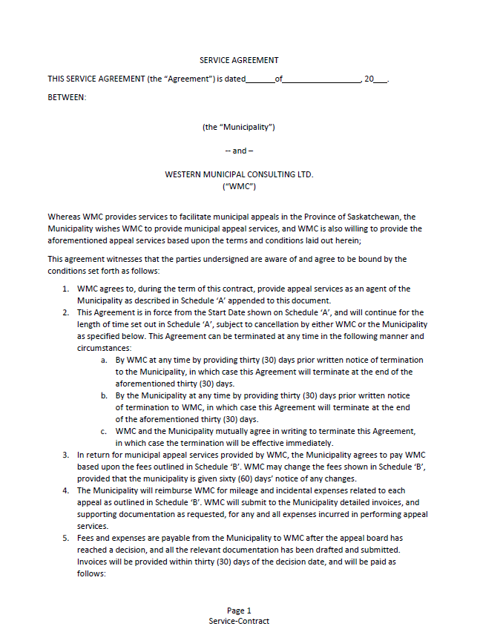
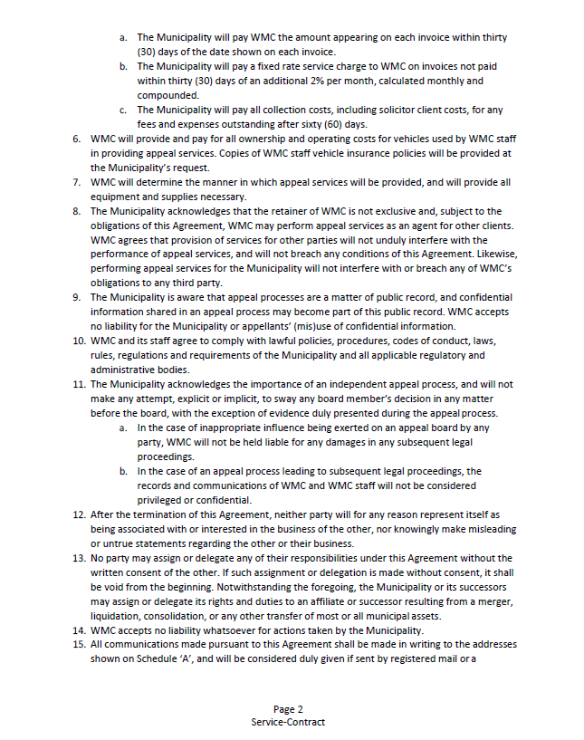
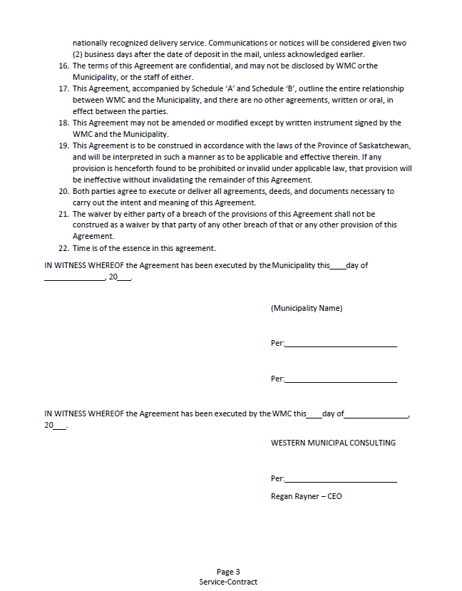
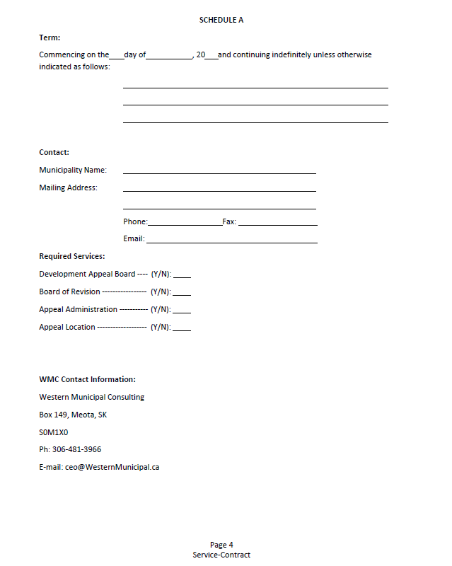
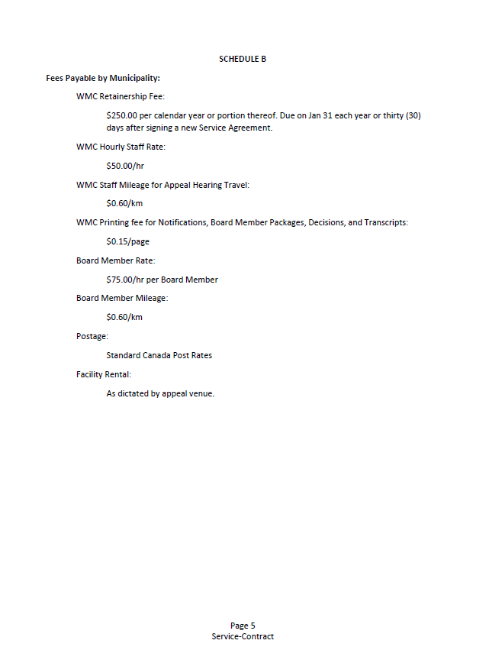
DECISION ITEM

Subject | UMAAS Convention
Council Meeting Date Presented: | April 2, 2022
Agenda Item: | 8.4
Prepared By: | Heather Scott CAO

BACKGROUND:
- The Urban Municipal Administrator Association of Saskatchewan (UMAAS) holds their Annual Convention typically in June every year at the Travel Lodge in Saskatoon.
- Due to COVID-19 restrictions, the annual in person convention has been postponed for the past two years.
- In 2022, the organization is planning on returning to the in person format for the convention.
- The convention is typically a very well organized event which focuses on information and training geared for administrators including important upcoming changes in legislation, onsite training and informational sessions, networking with other administrators and engagement with the Minister’s office.
- The administrator would like to request attendance at all or a portion of this year’s convention being held June 7 – 10, 2022.
- Based on the June 7th Council meeting date, it is acknowledge that if approved, the administrator would not leave until after the meeting has concluded.

BUDGET & OTHER CONSIDERATIONS:
- The delegate costs are usually $165 - $175
- Hotel costs for three nights at the UMAAS group rate of $114 per night
- Anticipated total costs between $500 - $600 for travel, hotel and convention fee
RECOMMENDATION:
- That Council approve attendance of the Administrator at the 2022 UMAAS Convention.
- I don’t believe it would be beneficial for the administrator to attend this year to keep up to date on any legislative changes and opportunity for networking and introducing delegates and business partners to the Resort Village of Elk Ridge.
PROPOSED MOTION:

That Council approve attendance of the Administrator at the 2022 UMAAS Convention.

Respectfully Submitted by: Heather Scott, CAO

Administrator Report – April 12, 2022

- Administration has posted an RFP for web design services and been working with interested parties in providing information.
- Assessment appeal board of revision has dissolved. Working on getting information for the company our former members have hired to manage their appeals this year.
- Contact with Building inspector on changes to building regulations as it relates to plumbing permits and discovered that the change is that the permits are now taken by the Technical Safety Authority of Saskatchewan (TSASK). These permits were previously authorized by the Public Health Authority.
- SAMA maintenance list to ensure that inspections are up-to-date.
- Declaration to qualify for Municipal revenue sharing has been completed and sent in.
- Administration has been working a lot this week with the Ministry of Finance and Government relations to continue to obtain accounts and access to the various Government sites to be able to enter Income tax deductions and SETS Education tax updates.
- Service agreement with Gary Provencher has now been executed by both parties.
- On March 24th, the Administrator attended the RMAA workshop “Dealing with Difficult Conversations”. This workshop was very interesting.
- The Administrator has been working with the Affinity Credit Union to set up the CAFT program which would enable the Resort Village of Elk Ridge residents to sign up for automatic monthly withdrawals for tax payments and the program will be up and running in the next few weeks.
- Preliminary budget work has been started. It is anticipated that there will be a budget meeting in the near future to review.
- The bylaw review has continued with the Transition Advisory Committee. There are many bylaws in the process of final review before being presented to Council at a meeting in the near future.
- The Mayor and administrator have met with Fire Chief Chris McShannock following a structure fire in the community. We were updated on the safeguards in place for our community, the partnerships and some of the anticipated future plans of the Fire Services. The Fire Chief has been invited to present to all of Council at the April Council meeting.

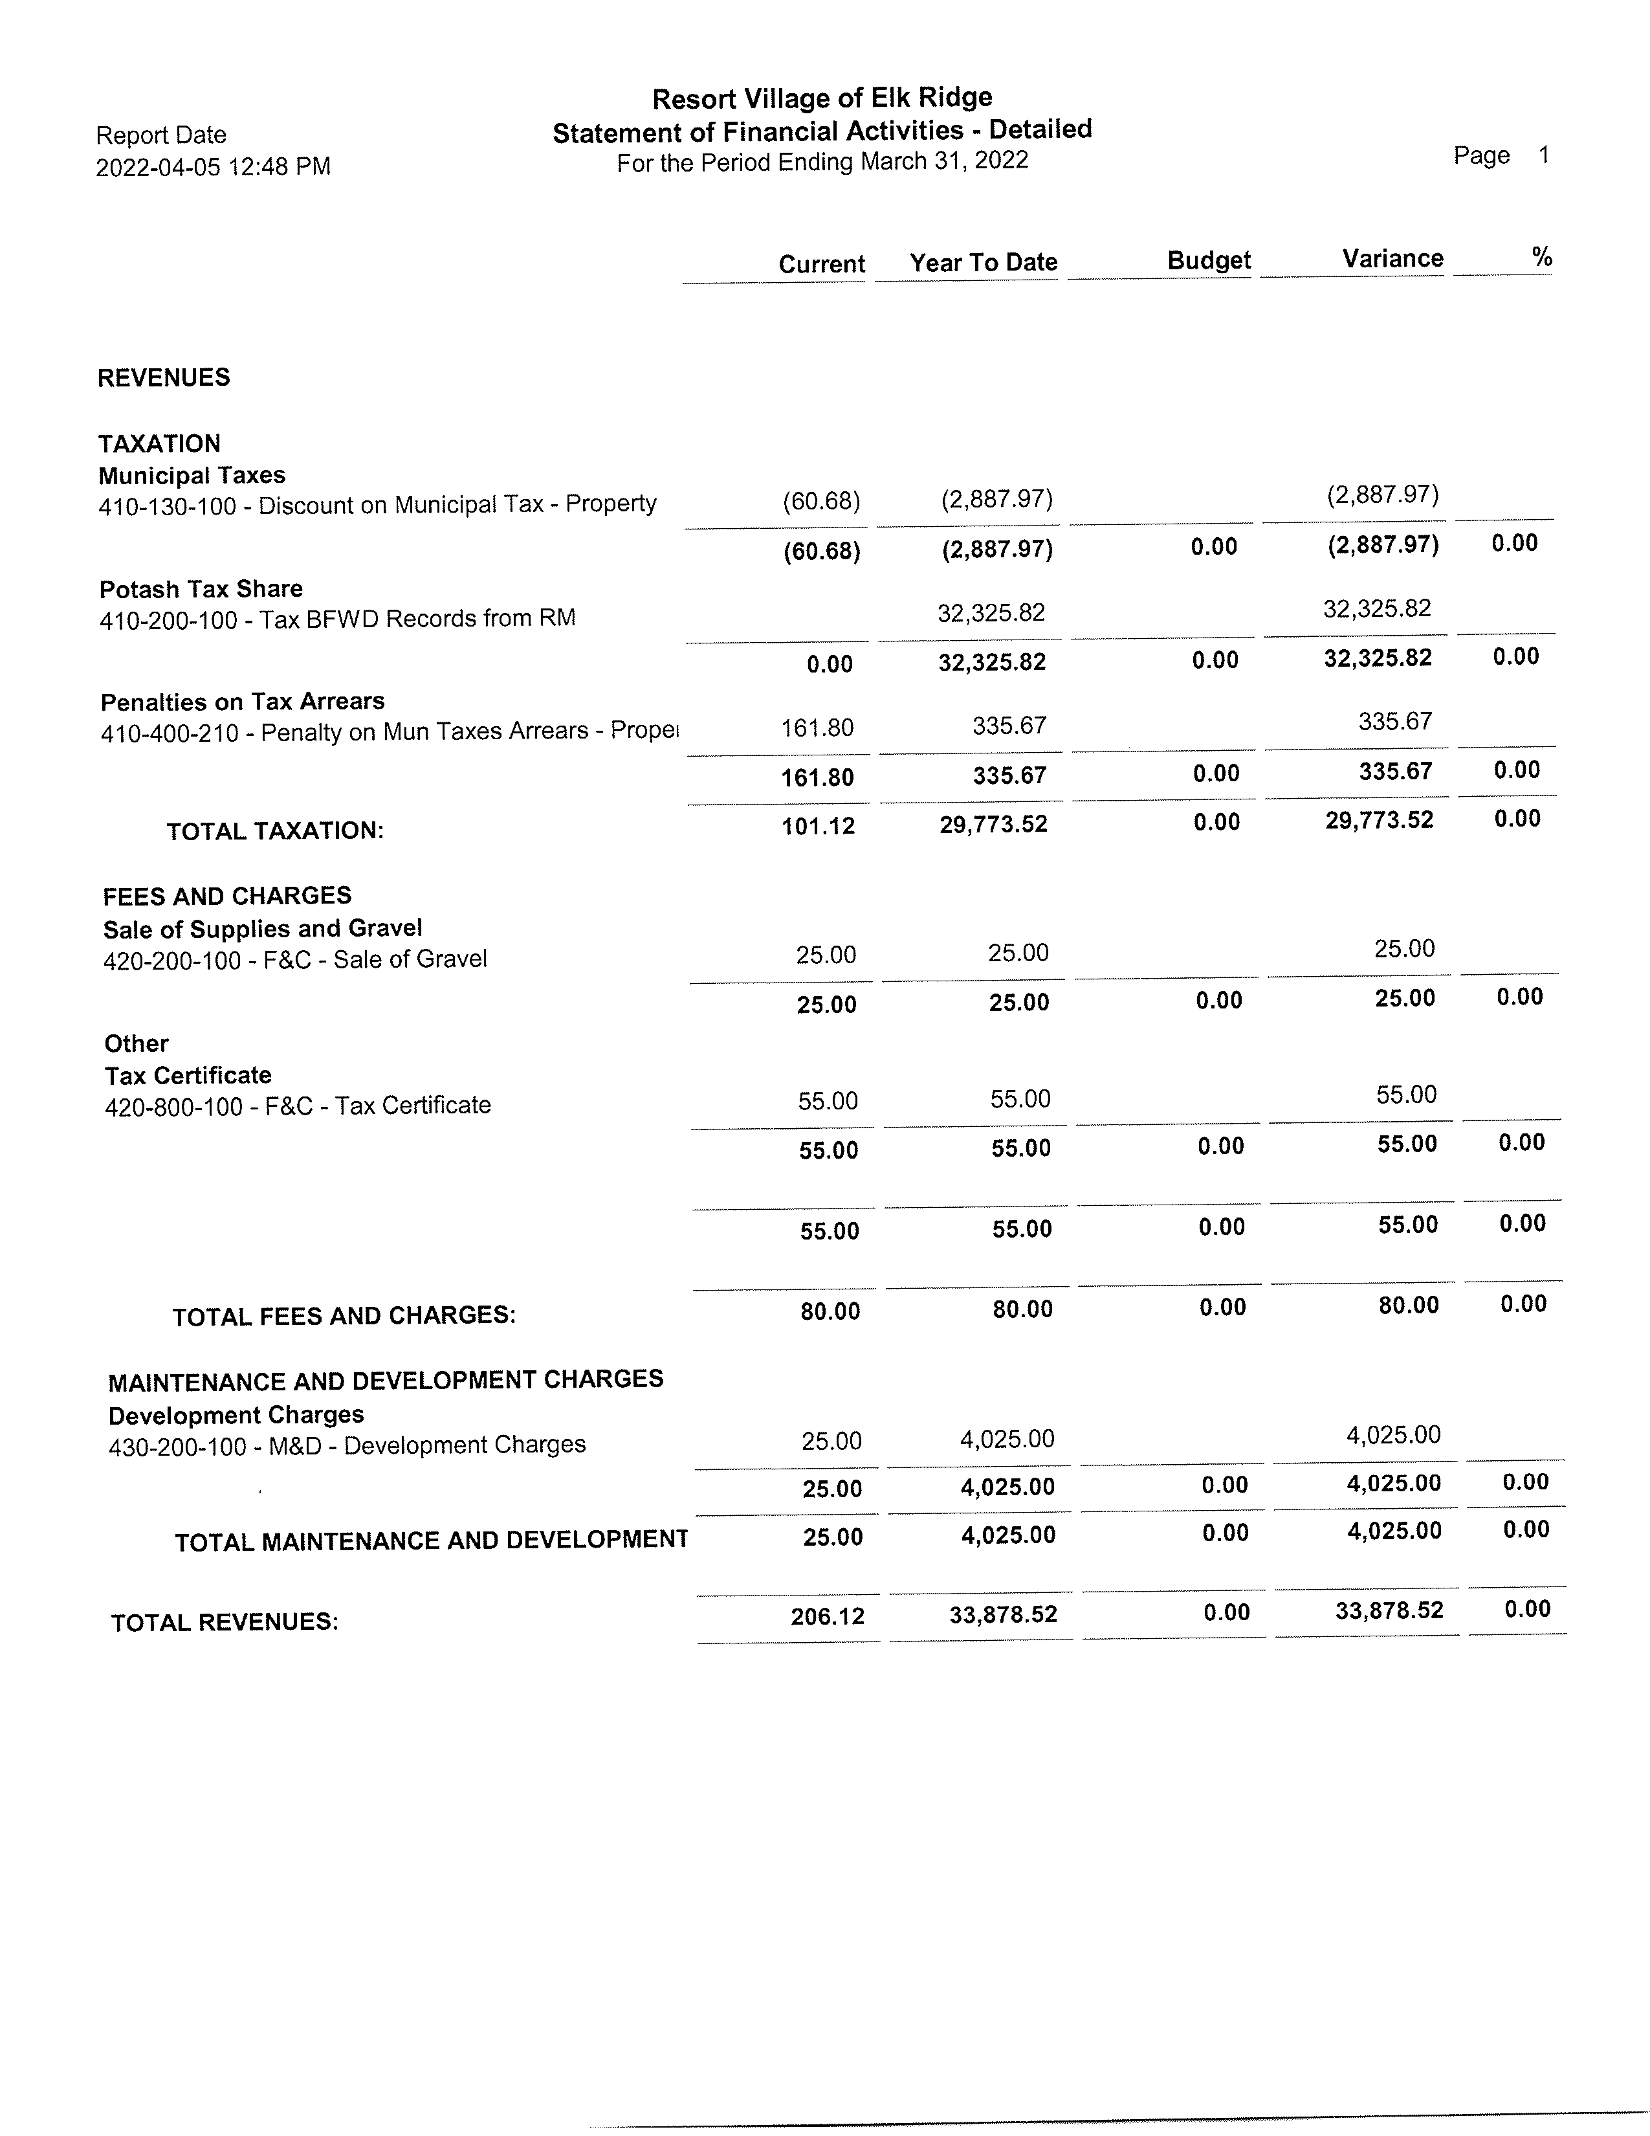
Registration Form
Please complete this form and the Confirmation of Voting Delegate form (see attached) and return them, along with payment of your registration fee, to SAMA.

Name(s) | Voting Delegate* | Non-Voting Participant** | Attending Virtually*** | Training Session

Representing:

(Municipality)_________________________________________________________________

Business Address: ______________________________________________________________

_____________________________________________________________________________

If attending virtually, please provide the email address you would like SAMA to send the link to: _____________________________________________________________________________

Registration Fee:

Until March 31: $75 per person (GST included)
After March 31: $85 per person (GST included)
Virtual Registration Fee: $25 (GST included)

Please make cheques payable to the Saskatchewan Assessment Management Agency. To pay with a credit card please contact SAMA at 306-924-8000.

Please indicate what and who has dietary restrictions (if applicable) ____________________________

___________________________________________________________________________________

A block of hotel rooms has been set aside at the Hilton Garden Inn. Rooms can be booked by contacting the hotel at 306-244-2311 and referencing SAMA, or by clicking this link: Book your group rate for SAMA.

*A voting delegate is a person named by the municipal council and must complete the confirmation form on the reverse side. Municipalities can name up to two (2) voting delegates.
**A non-voting participant must be appointed by a municipal council or invited by the board as a representative of a group or organization interested in assessment matters.
*** Only in-person attendees can vote on resolutions.

Confirmation of Voting Delegate(s)

Please complete this form and the Registration Form (see attached) and return them, along with payment of your registration fee, to SAMA.

1st Voting Delegate:

______________________________________________________________________________
(Name of Delegate)

Has been appointed by:

___________________________________________________________ Municipal Council

to attend SAMA’s 2022 Annual Meeting as its voting delegate.

______________________________________________________________________________
Signed by
(Mayor, Reeve, Clerk or Administrator)

2nd Voting Delegate:

______________________________________________________________________________
(Name of Delegate)

Has been appointed by:

___________________________________________________________ Municipal Council

to attend SAMA’s 2022 Annual Meeting as its voting delegate.

______________________________________________________________________________
Signed by
(Mayor, Reeve, Clerk or Administrator)

