Resort Village of Elk Ridge
Meeting Agenda
August 9th, 2022 at 3:00 p.m. – Regular Meeting – Elk Ridge Golf Resort

- Call to Order – The Mayor called the meeting of Council to order.
- Delegations:
2.1 – Page 3 - Darcy Simoneau – R2SK RV Park
2.2 - Jim Walters, Crosby Hannah & Associates.
- Approval of Agenda:
MOTION: That the agenda for this meeting be approved as presented.
- Public Hearings: None
- Reading of Bylaws:
5.1 – Bylaw 02 of 2022 - Building Bylaw
5.2 - Bylaw 27 of 2022 - Open Air Fire Restriction Bylaw
5.3 – Bylaw 12 of 2022 – Traffic Bylaw
- Adoption of Minutes:
6.1 Page 4– Minutes of the July 12th, 2022 meeting.
MOTION: That the Minutes of the July 12th, 2022 Meeting be approved as presented.
6.2 Page 12– Minutes of the July 29, 2022 Special Meeting.
MOTION: That the Minutes of the July 29th, 2022 Special Meeting be approved as presented.
- Business Arising from Minutes: None
- Action/Motion Items:
  - Page 14– Council Committee Appointments: Executive Committee, Public Works Committee and Finance Committee
  - Page 18– Surplus Investment
- Administration Reports:
9.1 Page 19-CAO Report and Updates
- Accounts for Payment:
- Financial Statements:
  - Page 21– Financial Statement for June, Bank Reconciliation and List of Accounts
MOTION: That Council receive and file the financial statement, bank reconciliation and list of accounts payable for July, 2022.
- Council Divisional Reports: N/A
- New Business:
- Incamera:
- Correspondence:
  - Page 30 - Email dated July 25th, 2022 from Wendy Gowda.
- Other Business:
- Adjournment

From: Darcy Simoneau
Sent: July 21, 2022 12:07 PM
To: Trudy Engel
Cc: Darcy Simoneau
Subject: Seasonal RV Park - Resort Village Annual Site cost proposal 2022

Mr Mayor and Councillors:

This is a request to review, and if possible reduce, 2022 costs for the RV site annual fee as previously approved by council. This request is being made due to delays caused by weather, subcontractor delays and labour shortages.

One note is that the RM of Lakeland bylaws for RV sites, that we assumed were going to be the same as The Resort Village was to incorporate, was that a site needed to be occupied to be charged for.

Currently we have 30 sites that will be occupied for the balance of 2022 based on delays that have occurred and the season being half over. We are anticipating full occupancy for 2023 of all 58 sites.

1. Proposed cost per serviced occupied site based on a full season of Approx 148 days - May 15th - Oct 10th - $ 325.00 each

2. Actual site opening day 2022 July 29th - 30 sites will be occupied with-in 5-7 days of this date.

3. Resort Village Revenue is $2.20 per day based on 148 days - propose paying for 75 days which equates to $ 165.00 for 30 sites to be billed July 29th, 2022.

We appreciate the consideration by council for this relief, as R2SK is already bearing annual revenue reductions for the sites, as well as resort revenue from residents of those sites due to delays on the project.

Thank you
Darcy Simoneau
R2SK Shareholder and Seasonal RV Park Liason.

Resort Village of Elk Ridge
Meeting Minutes
July 12th, 2022 Regular Meeting of Council

A Regular Meeting of Council of the Resort Village of Elk Ridge was held at the Elk Ridge Golf Resort on July 12, 2022.

Present: Mayor Garry McKay
Councillor Ryan Danberg
Councillor Trudy Engel
Councillor Ross Hewett
Councillor Margaret Smith-Windsor

Heather Scott, CAO

- Call to Order – With a quorum being present, Mayor Garry McKay called the meeting to order at 3:00 p.m.

- Delegations: None

- Approval of Agenda:

146-2022 ENGEL: That two additions be added to the agenda:
- Request for meeting with Utility Board; and
- Motion that Council go incamera to discuss a personnel matter. CARRIED

147-2022 SMITH-WINDSOR: That the agenda for this meeting be approved as amended.
- CARRIED
- Public Hearings: None
- Reading of Bylaws: None

- Adoption of Minutes:
6.1 - Minutes of the June 14th, 2022 Council Meeting.
148–2022 HEWETT: That the Minutes of the June 14th, 2022 Council Meeting be approved as presented. CARRIED

- Business Arising from Minutes: None
- Action/Motion Items:
8.1 – Transition Advisory Committee Bylaw Recommendations:
149-2022 ENGEL: That Bylaw 03-2022 the Code of Ethics Bylaw be introduced and read a first time. CARRIED
150-2022 HEWETT: That Bylaw 03-2022 the Code of Ethics Bylaw be now read a second time. CARRIED
151-2022 DANBERG: That leave be granted for third reading of Bylaw 03 of 2022 the Code of Ethics Bylaw. UNANIMOUSLY CARRIED

152-2022 SMITH-WINDSOR: That Bylaw 03 of 2022 the Code of Ethics Bylaw be read a third time and adopted. CARRIED

153-2022 ENGEL: That Bylaw 04-2022 the Administrative Bylaw be introduced and read a first time. CARRIED
154-2022 HEWETT: That Bylaw 04-2022 the Administrative Bylaw be now read a second time. CARRIED
155-2022 DANBERG: That leave be granted for third reading of Bylaw 04 of 2022 the Administrative Bylaw. UNANIMOUSLY CARRIED

156-2022 SMITH-WINDSOR: That Bylaw 04 of 2022 the Administrative Bylaw be read a third time and adopted. CARRIED
157-2022 ENGEL: That Bylaw 06-2022 the Tax Certificates and Assessment Bylaw be introduced and read a first time. CARRIED

158-2022 HEWETT: That Bylaw 06-2022 the Tax Certificate and Assessment Bylaw be now read a second time. CARRIED
159-2022 DANBERG: That leave be granted for third reading of Bylaw 06 of 2022 the Tax Certificate and Assessment Bylaw. UNANIMOUSLY CARRIED

160-2022 SMITH-WINDSOR: That Bylaw 06 of 2022 the Tax Certificate and Assessment Bylaw be read a third time and adopted. CARRIED

161-2022 ENGEL: That Bylaw 08-2022 the Nuisance Abatement Bylaw be introduced and read a first time. CARRIED
162-2022 HEWETT: That Bylaw 08-2022 the Nuisance Abatement Bylaw be now read a second time. CARRIED
163-2022 DANBERG: That leave be granted for third reading of Bylaw 08 of 2022 the Nuisance Abatement Bylaw. UNANIMOUSLY CARRIED

164-2022 SMITH-WINDSOR: That Bylaw 08 of 2022 the Nuisance Abatement Bylaw be read a third time and adopted. CARRIED

165-2022 ENGEL: That Bylaw 11-2022 the Bylaw to Dispense with the Mailing of Assessment Notices be introduced and read a first time. CARRIED
166-2022 HEWETT: That Bylaw 11-2022 the Bylaw to Dispense with the Mailing of Assessment Notices be now read a second time. CARRIED
167-2022 DANBERG: That leave be granted for third reading of Bylaw 11 of 2022 the Bylaw to Dispense with the Mailing of Assessment Notices.
UNANIMOUSLY CARRIED

168-2022 SMITH-WINDSOR: That Bylaw 11 of 2022 the Bylaw to Dispense with the Mailing of Assessment Notices be read a third time and adopted. CARRIED

Councilor Danberg having declared a conflict of interest left at 3:15 p.m.

169-2022 ENGEL: That Bylaw 13-2022 the Trailer License Fee Bylaw be introduced and read a first time. CARRIED
170-2022 HEWETT: That Bylaw 13-2022 the Trailer License Fee Bylaw be now read a second time. CARRIED
171-2022 MCKAY: That leave be granted for third reading of Bylaw 13 of 2022 the Trailer License Fee Bylaw. UNANIMOUSLY CARRIED

172-2022 SMITH-WINDSOR: That Bylaw 13 of 2022 the Trailer License Fee Bylaw be read a third time and adopted. CARRIED

Councilor Danberg returned at 3:17 p.m.

173-2022 ENGEL: That Bylaw 14-2022 the Public Notice Bylaw be introduced and read a first time. CARRIED
174-2022 HEWETT: That Bylaw 14-2022 the Public Notice Bylaw be now read a second time. CARRIED
175-2022 DANBERG: That leave be granted for third reading of Bylaw 14 of 2022 the Public Notice Bylaw. UNANIMOUSLY CARRIED

176-2022 SMITH-WINDSOR: That Bylaw 14 of 2022 the Public Notice Bylaw be read a third time and adopted. CARRIED

177-2022 ENGEL: That Bylaw 16-2022 the Employee Code of Conduct Bylaw be introduced and read a first time. CARRIED
178-2022 HEWETT: That Bylaw 16-2022 the Employee Code of Conduct Bylaw be now read a second time. CARRIED
179-2022 DANBERG: That leave be granted for third reading of Bylaw 16 of 2022 the Employee Code of Conduct Bylaw. UNANIMOUSLY CARRIED

180-2022 SMITH-WINDSOR: That Bylaw 16 of 2022 the Employee Code of Conduct Bylaw be read a third time and adopted. CARRIED

181-2022 ENGEL: That Bylaw 17-2022 the Civic Address Bylaw be introduced and read a first time. CARRIED
182-2022 HEWETT: That Bylaw 17-2022 the Civic Address Bylaw be now read a second time. CARRIED
183-2022 DANBERG: That leave be granted for third reading of Bylaw 17 of 2022 the Civic Address Bylaw. UNANIMOUSLY CARRIED

184-2022 SMITH-WINDSOR: That Bylaw 17 of 2022 the Civic Address Bylaw be read a third time and adopted. CARRIED

185-2022 ENGEL: That Bylaw 18-2022 the Animal Control Bylaw be introduced and read a first time. CARRIED
186-2022 HEWETT: That Bylaw 18-2022 the Animal Control Bylaw be now read a second time. CARRIED
187-2022 DANBERG: That leave be granted for third reading of Bylaw 18 of 2022 the Animal Control Bylaw. UNANIMOUSLY CARRIED

188-2022 SMITH-WINDSOR: That Bylaw 18 of 2022 the Animal Control Bylaw be read a third time and adopted. CARRIED

189-2022 ENGEL: That Bylaw 20-2022 the Bylaw to Establish an EMO be introduced and read a first time. CARRIED
190-2022 HEWETT: That Bylaw 20-2022 the Bylaw to Establish an EMO be now read a second time. CARRIED
191-2022 DANBERG: That leave be granted for third reading of Bylaw 20 of 2022 the Bylaw to Establish an EMO. UNANIMOUSLY CARRIED

192-2022 SMITH-WINDSOR: That Bylaw 20 of 2022 the Bylaw to Establish an EMO be read a third time and adopted. CARRIED

193-2022 ENGEL: That Bylaw 21-2022 the Sewage Disposal Bylaw be introduced and read a first time. CARRIED
194-2022 HEWETT: That Bylaw 21-2022 the Sewage Disposal Bylaw be now read a second time. CARRIED
195-2022 DANBERG: That leave be granted for third reading of Bylaw 21 of 2022 the Sewage Disposal Bylaw. UNANIMOUSLY CARRIED

196-2022 SMITH-WINDSOR: That Bylaw 21 of 2022 the Sewage Disposal Bylaw be read a third time and adopted. CARRIED

197-2022 ENGEL: That Bylaw 22-2022 the Waste Collection and Recyclable Bylaw be introduced and read a first time. CARRIED
198-2022 HEWETT: That Bylaw 22-2022 the Waste Collection and Recyclable Bylaw be now read a second time. CARRIED
199-2022 DANBERG: That leave be granted for third reading of Bylaw 22 of 2022 the Waste Collection and Recyclable Bylaw. UNANIMOUSLY CARRIED

200-2022 SMITH-WINDSOR: That Bylaw 22 of 2022 the Waste Collection & Recyclable Bylaw be read a third time and adopted. CARRIED

- Administration Reports:
  - CAO Report and Updates.
201-2022 SMITH-WINDSOR: That Council direct the CAO to make a request to the Department of Highways for a turning lane on the west side of Highway 263 into Elk Ridge. CARRIED

202-2022 SMITH-WINDSOR: That Council receive and file the CAO report for July, 2022. CARRIED
- Accounts for Payment: N/A
- Financial Statements:
11.1 Financial Statement for June 2022, Bank Reconciliation and List of Accounts.
203-2022 ENGEL:
That Council receive and file the financial statement, bank reconciliation and list of accounts payable for June, 2022 with an updated financial statement be forwarded to Council. CARRIED
- Council Divisional Reports: N/A
- New Business:
204-2022 MCKAY:
That a letter be forwarded to the Elk Ridge Utility Ltd. Board requesting a meeting to discuss the merits of establishing a joint committee with a mandate to recommend a long-term governance model that will provide for the efficient and sustainable delivery of sewer and water services within the Resort Village of Elk Ridge. CARRIED

205-2022 ENGEL:
That the Mayor, Councilor Danberg and Councilor Engel be the designated Council representatives for the proposed meeting. CARRIED

- Incamera:
206-2022 ENGEL:
That Council move to incamera meeting to discuss a personnel matter at 5:42 p.m.
CARRIED
Heather Scott, CAO left the meeting at 5:42 p.m.

207-2022 SMITH-WINDSOR:
That Council reconvene to regular Council meeting at 6:36 p.m. CARRIED
- Correspondence: None
- Other Business: None
- Adjournment:
208-2022 ENGEL: That the meeting adjourn 6:37 p.m. CARRIED

_____________________________ ___________________________
Mayor CAO

Resort Village of Elk Ridge
Meeting Minutes
July 29th, 2022 Special Council Meeting

A Special Meeting of Council of the Resort Village of Elk Ridge was held at the Elk Ridge Golf Resort on July 29, 2022.

Present: Mayor Garry McKay
Councillor Ryan Danberg
Councillor Trudy Engel
Councillor Ross Hewett
Councillor Margaret Smith-Windsor

Heather Scott, CAO

- Call to Order – The Mayor called the meeting of Council to order at 6:28 p.m.
- Delegations: Darcy Simoneau & Nevin Anderson – RV Park Septic Request
- Approval of Agenda
209-2022 SMITH-WINDSOR: That the Agenda for this meeting be approved and a welcome extended to Darcy and Nevin. CARRIED
- Public Hearings: None
- Reading of Bylaws: None
- Adoption of Minutes: None
- Business Arising from Minutes: None
- Action/Motion Items: None
- Administration Reports: None
- Accounts for Payment: None
- Financial Statements: None
- Council Divisional Reports: N/A
- New Business
  - – RV Park Temporary Septic Storage Request.
210-2022 HEWETT: That Council approve the RV Park Request dated July 29, 2022 for temporary internal storage of the lift station holding chamber as a waste management system until October 10th, 2022 providing full compliance with Bylaw 21 -2022 a Bylaw to Control the Collection, Storage and Disposal of Sewage. CARRIED

- Incamera: N/A
- Correspondence: None
- Other Business: None
- Adjournment:
211-2022 HEWETT: The meeting adjourn at 7:15 p.m. CARRIED

_____________________________ ___________________________
Mayor CAO

DECISION ITEM

Subject | Council Committee Appointments
Council Meeting Date Presented: | August 2, 2022
Agenda Item: | 8.1
Prepared By: | Heather Scott CAO

BACKGROUND:
- Council has requested the formation of several standing committees of Council to assist with municipal operations.
- Section 81 of The Municipalities Act provides municipal Council’s the ability to establish council committees and other bodies and define their function.
- Administration has drafted three terms of reference for three committees requested by Council:
- Executive Committee;
- Public Works Committee; and
- Finance Committee
BUDGET & OTHER CONSIDERATIONS:
- N/A
RECOMMENDATION:
- That Council review the proposed terms of reference and appoint Council members to each committee;
- Approve the establishment of each committee and approve the corresponding Terms of Reference.
PROPOSED MOTION:

- That Council approve the Terms of Reference for the creation of an Executive Committee;
- That Council approve the Terms of Reference for the creation of a Public Works Committee;
- That Council approve the Terms of Reference for the creation of a Finance Committee.

Respectfully Submitted by: Heather Scott, CAO


RESORT VILLAGE OF ELK RIDGE
TERMS OF REFERENCE
EXECUTIVE COMMITTEE

PURPOSE:
To provide support and direction to the CAO in between Council meetings when requested.

GOVERNANCE:
The Committee is responsible to Council.

MEMBERS:
- Mayor as Chairperson
- Deputy Mayor
- Deputy Mayor next in rotational order
- CAO, Advisor

FUNCTION:
To provide support and direction to the CAO by making minor decisions and providing feedback on behalf of Council without the formality of a Council meeting.

MEETINGS:
As required

RESORT VILLAGE OF ELK RIDGE
TERMS OF REFERENCE
PUBLIC WORKS COMMITEE

PURPOSE:
To provide support and direction to the CAO on matters dealing Public Works within the Resort Village of Elk Ridge.

GOVERNANCE:
The Committee is responsible to Council.

MEMBERS:
1. , Chairperson
2.
3. CAO, Advisor

FUNCTION:
To provide support and direction to the CAO on matters dealing with Public Works and oversee public works projects and work in the absence of the CAO.

MEETINGS:
As required

RESORT VILLAGE OF ELK RIDGE
TERMS OF REFERENCE
FINANCE COMMITEE

PURPOSE:
To provide support and direction to the CAO on matters dealing with the financial reporting of the Resort Village of Elk Ridge.

GOVERNANCE:
The Committee is responsible to Council.

MEMBERS:
1. , Chairperson
2.
3. CAO, Advisor

FUNCTION:
To provide support and direction to the CAO on matters dealing with the financial reporting of the Resort Village of Elk Ridge.

MEETINGS:
As required

DECISION ITEM

Subject | Municipal Investment Information
Council Meeting Date Presented: | June 29, 2022
Agenda Item: | 8.2
Prepared By: | Heather Scott CAO

` BACKGROUND:
- Council had requested that the CAO seek quotes for investment of municipal funds.
- In order to invest surplus municipal funds, an application must be sent to the Local Government Committee requesting approval to invest these funds.
- A Resort Village is only eligible to request approval invest municipal funds for one of the following:
- Government of Canada Bonds;
- Guaranteed Investment Certificates (GIC’s)
- Saskatchewan Municipal Securities;
- Saskatchewan School Division Securities;
- Deposit Certificates; or
- Shares In a Corporation.
- Administration as requested to bring quotes from at least two sources.
Affinity Credit Union | RBC
2 year GIC – 4% interest (locked in) | 2 year GIC – 2.5% Interest
1 year GIC – 3.35% interest (locked in) | - year GIC – 2 % Interest
- EQ Bank was also contacted to provide a quote but it was discovered that they do not offer business accounts and only offer personal accounts at this time.
BUDGET & OTHER CONSIDERATIONS:
- Interest Revenue dependant on which option Council chooses. Eg. $8,000 if $200,000 Is locked in a 2 year GIC @ 4%.

RECOMMENDATION:
- That Council choose the Affinity Credit Union 2 year GIC with a locked in rate of 4% or direct administration to research other options.
PROPOSED MOTION:

- That Council direct the CAO to send an application to the Local Government Committee for the investment of $______________ in a 2 year GIC with the Affinity Credit Union.

Respectfully Submitted by: Heather Scott, CAO

Administrator Report – August

New Updates:
- On July 19, 2022 I attended a SUMA webinar on the Importance of Date Reliability: What to look for. This was a new webinar series to discuss document management for a municipality and retaining and securing data in a digital age. Also, with very reliable data being stored on clouds and hard drives to ensure that the data is safe, reliable and accurate. The future evolution on data management and what new change may be coming forward in business practice was also included. Are electronic signatures and emails or data in electronic form reliable data? How does the legislation account for this? What hard copes are required to be retained by a government body?
- There have been 5 building permits issued so far this year. 4 for principal dwellings and one for a detached garage. There are also 4 other pending permits at various stages.
- The 30 yard garbage bin has been arranged for delivery on August 1 for one week. Upon speaking with Gary Provencher, he indicated that there were some larger items being collected and placed behind the regular garbage bins and these will be disposed of once the larger bin arrives. Notice was sent out to the community to advise of acceptable items for disposal.
- The BBQ on August was a success. We also had over 70 surveys completed at the event. Surveys will be sent via email for the rest of the community complete as well as be available at the municipal office. The Elk Ridge Resort Staff was very helpful and appreciated the effort by all who contributed toward making the bbq a success. The Resort is graciously only charging us for the burgers used at the bbq.
- The deductions previously being deducted from council indemnity was reimbursed with the July indemnity payment. It was discovered on review that the deductions weren’t necessary as the indemnity amounts do not meet the threshold to qualify for deductions.

Ongoing work in progress:
- The Department of Highways was contacted to thank them for the line painting as well as request the Elk Ridge Highway sign be stood up on the highway.
- Doug Neis who is the Department of Highways, Engineering and Development Department was also contacted to inquire as to the feasibility of a passing lane on Highway 264 at the entrance of Elk Ridge heading south out of the park. He indicated he would order a warrant analysis to be done to determine whether or not it would meet the qualifying points to be included in the next construction plan along Highway 264. Someone from that department will be in contact in the upcoming weeks to gather more information.
- Advisory Service has been advised that after Council query, the date that seems to work best for a governance workshop would be Thursday, September 8th, 2022. I am awaiting confirmation back if that date still works for them.
- Followed up with Canada Post main office as to the status of community mail boxes and new postal code as I haven’t heard back from my inquiries to the Christopher Lake Post Office. I was given a work ticket and advised to the follow up on August 23, 2022 if I haven’t heard anything by then.
- MEPP – Administration continues to work on reconciling the MEPP payments with Munisoft in the easy pay program. It should be completed shortly. I am now having to sort through each relevant GL batch related to the MEPP postings now that the easy pay reflects the accurate numbers.
- The website is coming along and should be prepared to launch very soon. There are a few revisions being made and a meeting being set up for next week to go over the website with MR Websites to finalize things.

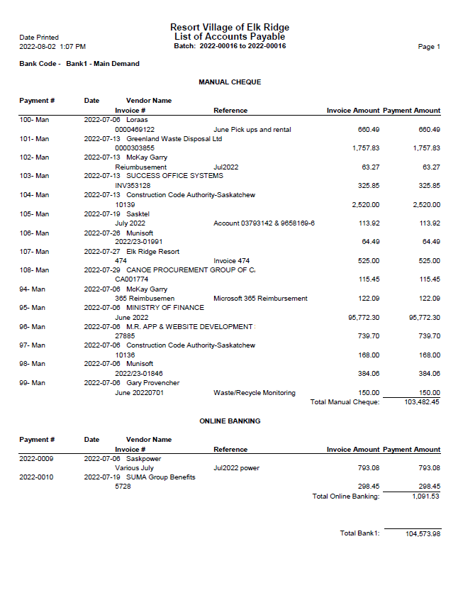
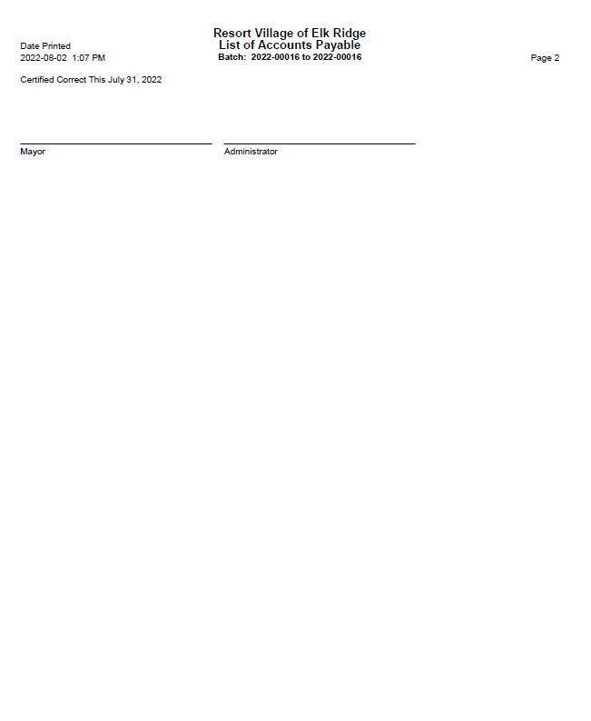

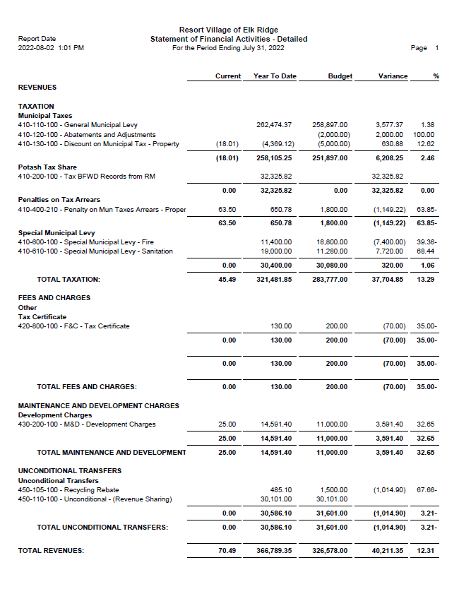
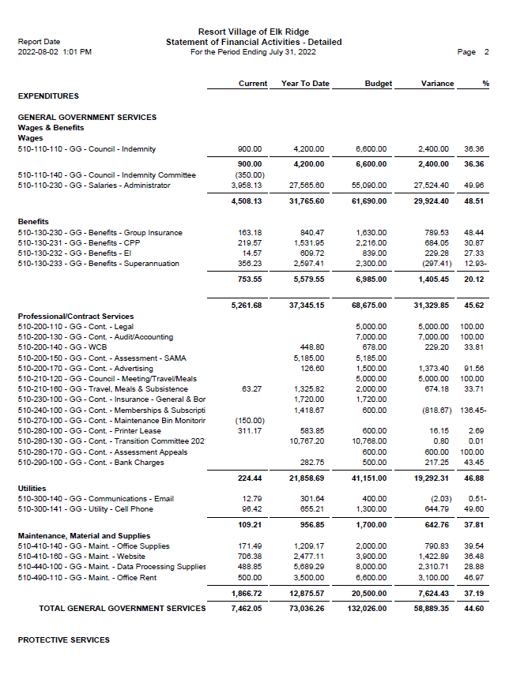
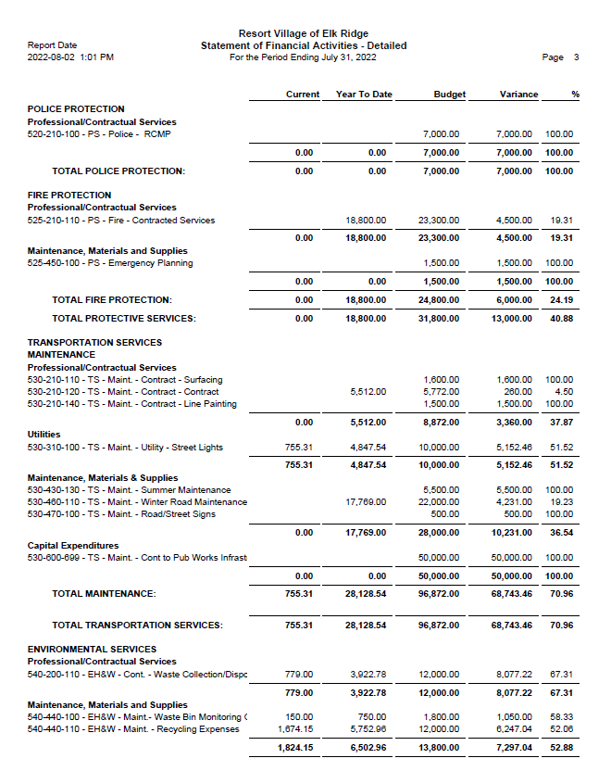
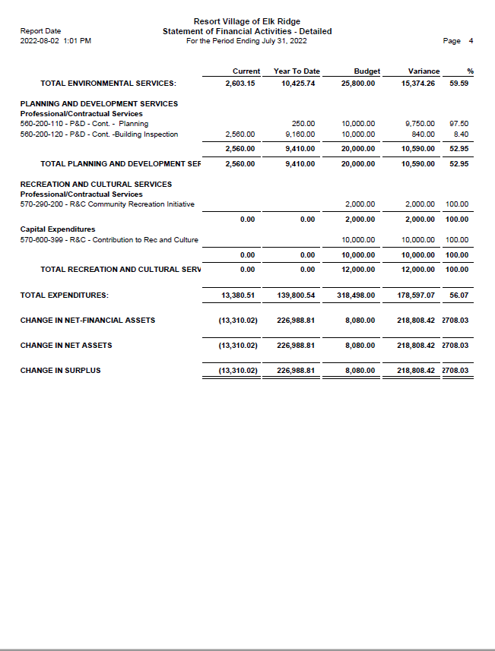
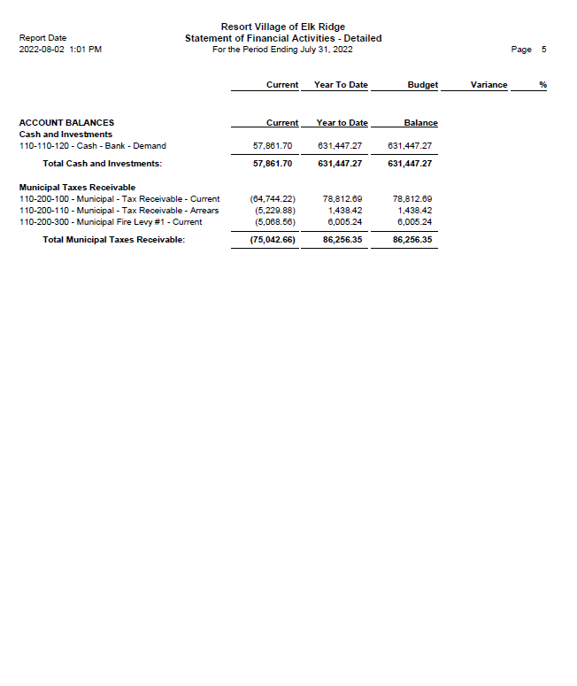

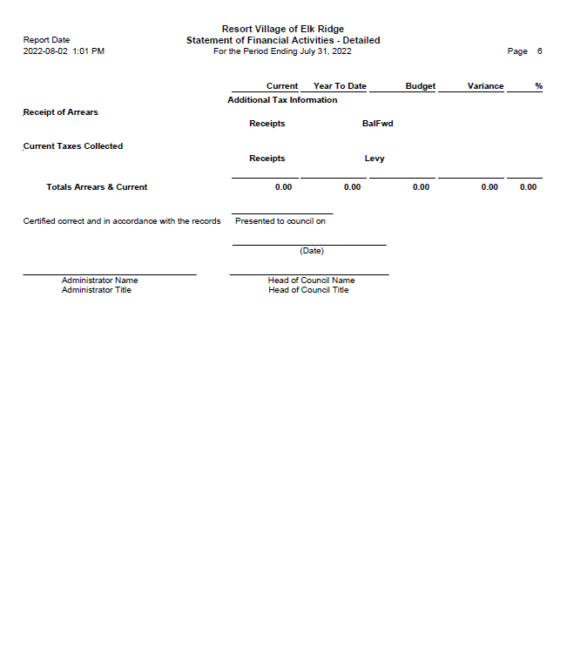

RESORT VILLAGE OF ELK RIDGE
Bank Reconciliation July 2022

GL 110-110-120 – General Ledger Account $631,447.27
- Bank Fees -47.54
- Cheque Order -144.61
- Unreceipted e-transfers 2006.68

Adjusted General Ledge Balance: $633,261.80

Bank Account Balance at July 31, 2022 $610,234.17
- Outstanding Cheques -3,687.78
- July Indemnity -492.66
- July Deposit 27,208.07

Adjusted Bank Balance $633,261.80

CAO Payroll:

July 15, 2022 - $1,293.04
July 30, 2022 - $1,332.67

Council Remuneration:

July 30, 2022 – Councilor - $109.483
Mayor - $164.22

From: w.gowda
Sent: July 25, 2022 7:51 AM
To: infoelkridge@sasktel.net
Cc: judy.kanak@gov.sk.ca
Subject: August 9th RV Meeting

Good Morning Heather,

Further to our July 19th meeting, and following an update and discussion with Ms, Kanak, with the
Ministry, please accept this email as confirmation that the settlement of the assets and liabilities
between the RV and the District will be completed as soon as possible following the acquisition of the
District's 2021 Audited Financial Statements, for which is anticipated to be in August, as per my recent
discussion with the RM Administrator.

Regrettably this work has taken longer than anticipated, however; this information is necessary prior to
making final adjustments between the municipalities. Please provide assurance to the RV elected
officials that it is in all of our interests to have resolution as soon as possible following receipt of the
statements; and adjustments will be forthcoming for for adjustments for the RV financial reporting and
the settlement of the assets and liabilities between the municipalities, to the date of incorporation.

Unfortunately, there is little more information that I can provide the elected officials at this time, and I
am declining to meet with the RV at the August 9th Meeting. I will keep you apprised of the financial
statements as they are available.

Regards,

Wendy Gowda

