Resort Village of Elk Ridge
Meeting Agenda
November 8th, 2022 at 3:00 p.m. – Regular Meeting – Elk Ridge Golf Resort

- Call to Order – The Mayor called the meeting of Council to order.
- Approval of Agenda:
MOTION: That the agenda for this meeting be approved as presented.
- Adoption of Minutes:
3.1 Page 3 – Minutes of the October 11th, 2022 meeting.
MOTION: That the Minutes of the October 11th, 2022 Meeting be approved as presented.
3.2 Page 6– Minutes of the November 1st, 2022 special meeting.
MOTION: That the Minutes of the November 1st, 2022 Special Meeting be approved as presented.
- Declaration of Conflict of Interest: None
- Delegations Scheduled:
  - Page 8 - Dennis Paddock, Elk Ridge Utility Re: Green Stream Infrastructure Funding
- Public Hearings:
- Public Acknowledgements:
- Business Arising from Minutes: None
- New Business: None
- Motions:
10.1 Page 9 – 2023 Suma Convention.
- Administration Reports:
  - Page 10-CAO Report and Updates
- Financial Reports:
12.1 Page 13 – Financial Statement for October Bank Reconciliation and List of Accounts
MOTION: That Council receive and file the financial statement, bank reconciliation and list of accounts payable for October, 2022.
- Reading of Bylaw(s): None
- Notice of Motion: None
- Inquiries: None
- In camera: None
- Information Items/Correspondence:
  - Page 16 - Minutes of the Executive Committee meetings held October 5 & 6, 2022.
  - Page 17 - Email from Brenda Wallace Re: Official Community Plan Update and Next Steps.
- Adjournment
Resort Village of Elk Ridge
Meeting Minutes
October 11th, 2022 Regular Meeting of Council

A Regular Meeting of Council of the Resort Village of Elk Ridge was held at the Elk Ridge Golf Resort on October 11th, 2022.

Present: Mayor Garry McKay (via Teams Meeting)
Councillor Ryan Danberg
Councillor Trudy Engel
Councillor Ross Hewett (via Teams Meeting)
Councillor Margaret Smith-Windsor

Heather Scott, CAO

- Call to Order – With a quorum being present, Mayor Garry McKay called the meeting to order at 3:00 p.m.

- Approval of Agenda:
251-2022 ENGEL: That the Agenda for this meeting be approved as presented.
SECONDED: HEWETT CARRIED

- Adoption of Minutes:
6.1 - Minutes of the September 13th, 2022 Council Meeting.
252–2022 HEWETT: That the Minutes of the September 13th, 2022 Council Meeting be approved as presented.
SECONDED: ENGEL CARRIED

- Declaration of Conflict of Interest: None
- Delegations Scheduled: None
- Public Hearings: None

- Public Acknowledgements: Councilor Danberg acknowledged the passing of Arne Petersen and his contribution to the community of Elk Ridge. A celebration of life will be held on Thursday at 2:00 p.m. at the Elk Ridge Resort.

- Business Arising from Minutes: None
- New Business: None
- Motions:
10.1 – Public Works Committee Minutes and updated Terms of Reference.
253-2022 SMITH-WINDSOR: That Council approve the Public Works Committee Updated Terms of Reference and receive and file the Minutes of the Public Works Committee Meeting dated September 19th, 2022.
SECONDED: HEWETT CARRIED

10.2 - Joint Committee with the Elk Ridge Utility Minutes.
254-2022 MCKAY: That the Resort Village of Elk Ridge confirm their participation in the joint committee consisting of four representatives appointed by the Elk Ridge Utility Ltd. and three representatives appointed by the Resort Village of Elk Ridge, be established with a mandate to review the feasibility of amalgamating Elk Ridge Utility Ltd. under the Resort Village of Elk Ridge and further;
That the Committee prepare and submit a final report to each party containing recommendation(s) including an Implementation Plan”; and
That the Resort Village of Elk Ridge representatives be Mayor McKay, Councilor Engel and Councilor Danberg.
SECONDED: SMITH-WINDSOR CARRIED

- Administrative Reports:
11.1 CAO Report for October 2022.
255-2055 DANBERG: That the CAO report of October 2022 be received and filed.
SECONDED: ENGEL CARRIED

- Financial Report:
12.1 – Financial Reports for September, 2022.
256-2022 DANBERG: That Council receive and file the financial statement, bank reconciliation and list of accounts payable for September, 2022.
SECONDED: HEWETT CARRIED

- Reading of Bylaw(s):
  - – Bylaw 27 of 2022 A Bylaw Respecting Open Air Fire Restriction.
257-2022 SMITH-WINDSOR: That Bylaw 27 of 2022 a Bylaw Respecting Open Air Fire Restriction be introduced and read a first time.
SECONDED: ENGEL CARRIED

258-2022 HEWETT: That Bylaw 27 of 2022 a Bylaw to Respecting Open Air Fire Restriction be now read a second time.
SECONDED: SMITH-WINDSOR CARRIED

259–2022 DANBERG: That leave be granted for the third reading of Bylaw 27 of 2022 a Bylaw Respecting Open Air Fire Restriction.
SECONDED: ENGEL UNANIMOUSLY CARRIED

260-2022 ENGEL: That Bylaw 27 of 2022 a Bylaw Respecting Open Air Fire Restriction be read a third time and adopted.
SECONDED: DANBERG CARRIED

- Notice of Motion: None
- Inquiries:
Website update from council meetings including snow removal & waste/recycling contracts and Fireworks, Open Fire Bylaw, Committee Updates.
- In camera: N/A
- Information Items/Correspondence: N/A
- Adjournment:
261-2022 DANBERG: That the meeting adjourn at 4:16 p.m.
SECONDED: HEWETT CARRIED

_____________________________ ___________________________
Mayor CAO

Resort Village of Elk Ridge
Meeting Minutes
November 1st, 2022 Special Meeting of Council

A Special Meeting of Council of the Resort Village of Elk Ridge was held at the Elk Ridge Golf Resort on November 1st, 2022.

Present: Mayor Garry McKay (via Teams Meeting)
Councillor Ryan Danberg
Councillor Trudy Engel
Councillor Ross Hewett
Councillor Margaret Smith-Windsor

Heather Scott, CAO

- Call to Order – With a quorum being present, Mayor Garry McKay called the meeting to order at 10:02 a.m.

- Approval of Agenda:
262-2022 SMITH-WINDSOR: That the agenda for this meeting be approved as presented.
SECONDED: ENGEL CARRIED
- Adoption of Minutes: None
- Declaration of Conflict of Interest: None
- Delegations Scheduled: None
- Public Hearings: None
- Public Acknowledgements: None
- Business Arising from Minutes: None
- New Business:
10.1 – Winter Road Maintenance RFP.
263-2022 SMITH-WINDSOR: That Council authorize the Resort Village of Elk Ridge to enter into an agreement with Lakeland Excavating Services Ltd. For Winter Road Maintenance for the 2022-2023 and 2023-2024 Winter Seasons.
SECONDED: HEWETT
Recorded Vote:
Smith-Windsor: Yes Danberg: Yes
Engel: Yes McKay: No
Hewett: Yes CARRIED
- Motions: None
- Administration Reports: None
- Financial Reports: None
- Reading of Bylaw(s): None
- Notice of Motion: None
- Inquiries: None
- In camera: None
- Information Items/Correspondence: None
- Adjournment:
264-2022 HEWETT: That the meeting adjourn at 10:39 a.m.
SECONDED: ENGEL CARRIED

_____________________________ ___________________________
Mayor CAO

On Oct 26, 2022, at 9:03 PM, Dennis Paddock < > wrote:
﻿
Mayor Garry McKay:

The Elk Ridge Utility is applying for a Green Infrastructure Stream grant from the Investing in Canada Infrastructure Program / Government of Saskatchewan to help with funding an estimated $660,000 upgrade of our Water Treatment Plant equipment. It would help our grant application if the Resort Village of Elk Ridge could pass a resolution in support of our application. The closing date for receiving applications is noon, November 29, 2022. We would suggest something like:

Whereas Elk Ridge Utility Ltd. requires a major upgrade of its water treatment plant equipment;

Whereas, Elk Ridge Utility Ltd. is requesting Federal and Provincial assistance for this upgrade through a Green Infrastructure Stream Grant from the Investing in Canada Infrastructure Program (ICIP) / Government of Saskatchewan; and,

Whereas a continued safe and reliable water supply to the residents and businesses of the Resort Village of Elkridge is critical;

Therefore be it resolved, that the Resort Village of Elk Ridge strongly endorse Elk Ridge Utility Ltd.'s water treatment plant equipment upgrade project and grant application.

We completed an engineering pre-design report, which we can provide to the resort village as soon as our Board completes its deliberation on the project. We are working to a tight timeline and ask you to consider our request at Council's first opportunity. If you have any questions, please call me.

Regards,
Dennis Paddock
President & Acting General M

DECISION ITEM

Subject | 2023 SUMA Convention
Council Meeting Date Presented: | November 8, 2022
Agenda Item: | 10.1
Prepared By: | Heather Scott CAO

BACKGROUND:
- The 2023 SUMA Convention alternates its location each year between Regina and Saskatoon.
- The 2023 Convention is scheduled to be held at TCU Place in Saskatoon between April 16-19, 2023.
- SUMA has just opened up their hotel bookings for the convention with a discounted SUMA rate. These room rates vary from each participating hotel from $114 -$189 per night. Most of these hotels are located in the downtown area for ease of accessibility to the venue.
- These bookings are already starting to fill up so it is recommended if the Resort Village of Elk Ridge is considering sending attendees to the 2023 convention, that administration be directed to reserve these rooms in advance.
BUDGET & OTHER CONSIDERATIONS:
- $114-$189 for each attendee for three nights. $342 – 567 for each attendee.
RECOMMENDATION:
- That Council authorize the CAO to book the necessary amount of rooms for the 2023 SUMA Convention.
- That the CAO try to find the most affordable booking available with the SUMA Rate.
PROPOSED MOTION:

- That Council direct the CAO to reserve _____ rooms for the 2023 SUMA Convention in Saskatoon from April 16-19, 2023.
Respectfully Submitted by: Heather Scott, CAO

ADMINISTRATOR'S REPORT: November 2022
Date | ADMINISTRATION HIGHLIGHTS: | Target
2022-10-30 | There are 11 new building permits so far this year; 9 for principal dwellings and 2 for a detached garage. | ongoing
2022-10-19 | Attended UMAAS/RMAA sponsored Community Planning Workshop - the workshop covered OCP's, Zoning Bylaws, Subdivision applications, Municipal and Environmental Reserves and the complete application process. There was a session specific for appeals, appeals boards and the enforcment of bylaws and regulations. Durfing the Q & A session the two presenters stressed the benefits of partnerships and the benefits of being in a district planning commission. Several smaller municipalities in attendance were struggling with the costs of hiring a planner to assist with developing a zoning bylaw and OCP and are currently operating without one and experiences several issues because of this. | completed
2022-10-31 | Telephone meeting with Dion Petz, representative MP Gary Vidal's office who has been assisting us with our mailbox requests to Canada Post. He indicated that he has spoke with his contact at Canada Post who has looked into our request and can confirm that it looks like our request is on the table for review in 2024 as their work schedule is already set for 2023. He also confirmed that it was not a simple process to set these things up and will continue to assist us in the future if progress stalls. | ongoing
Oct 26, 2022 | SUMAssure Presentation on the 2023 insurance renewal process - an overview of the forms and how to fill them out as well as resources available. | completed
2022-10-12 | Remotely attended SUMA North East Regional Meeting. The meeting had several welcoming greetings before getting into discussion. Each participating member took turns introducting themselves and talking about their pride in the community they were representing. The key part of the meeting was SUMA's governance review. They discussed their 2021-2025 Strategic Plan and the SUMA Board of Directors governance review. The Strategic Plan was pretty standards from past practice, but the Board of Directors Governance review is being changed to include a caucus model which would have more targeted members to represent a more inclusive community model. ie, more people on the board representing towns, villages, resort villages and northern villages. There was also an education session which went into depth on conflict of interest. | completed
Date | MISCELLANOUS | Target
 | Municipal Lawyer RFP | ongoing
 | municipal accountant RFP | ongoing
 | Update Development Applications with Elk Ridge Headers. Have not yet received converted copy. Will try sending to a new source. | ongoing
Date | MINUTES FOLLOW UP | Target
2022-10-28 | Pursuant to Motion 10.2 - Joint Committee with the Elk Ridge Utility Minutes.  254-2022, the Mayor advised the Utility of the appointment of Mayor McKay, Councilor Engel and Councilor Danberg as the representative for the Resort Village. | Complete
10-28-2022 | Website update from council meetings - Would this be in the form of a message from the mayor or council | ongoing
Date | COMMITTEES | Target
2022-09-19 | The Public Works Committee met Oct 25, 2022 to review the Winter Road Maintenance RFP results and provide a recommendation to Council for this contract.  Council awarded to the contract to Lakeland Excavating at a special meeting held November 1, 2022 | complete
2022-11-08 | The Public Works Committee is meeting November 8th, 2022 to review and discuss the results of the waste and recycling RFP submissions in an effort to be able to provide a recommendation for awarding the contract or direction forward on next steps. | ongoing
2022-09-20 | EMO Plan development. L. Tuchek has been engaged to assist. I had a meeting with Ms. Tuchek on October 11th, were she provided me with a template from BC to populate and made a recommendation that someone from Elk Ridge attend the SEPA Conference in the future. The conference this year is Nov 9 & 10 so there wasn't much time to make arrangements for this year, but something to think about and budget for 2023. | 31-Dec-22
Date | HIGHWAYS | Target
2022-09-27 | A response was received from Austin Gee, Engineer for the Ministry of Highways with respect to request for south bound passing or turning lane coming from the PANP past Elk Ridge. Mr. Gee indicated that their analysis has been completed and it is not recommended at this time bt their Traffic Engineering Dept Team will continue to monitor the intersection and reassess it in the event of a major rehabilitation for Highway 264. | 31-Dec-23
2022-09-07 | An application was sent to the Minstry for a quote for a municipal highways sign. Response has not yet been received. Follow up with Mike Guitard, District Operations Manager in Oct requesting update or eta on a quote for the sign. | Follow up Nov 20, 2022
2022-09-07 | The Ministry was contacted with a request made to fix the Elk Ridge Sign laying in the ditch southbound from the PANP. No response has been provided and the sign has not yet been repaired. Follow up sent to Mike Guitard in Oct requesting update or eta on when sign can be repaired. | Follow up Nov 20, 2022
Date | GRANT UPDATES/UPCOMING | Target
2022-09-15 | Crosby Hanna applied for the second intake for the TSS Targeted Sector Initiative Grant for their work associated with the planning partners zoning and development bylaws. This grant covers 75% of eligible costs leaving municipalities with 25%. | Awaiting to hear if application was successful.
Date | PUBLIC WORKS | Target
2022-09-04 | The fireban and speed signs have arrived. CAO has worked with Resort Maintenance Dept to have the speed sign put up. Al also installed a bolt to attach the fireban sign when needed, an internal location is being identified to post the second sign in the event of a ban going into effect. | complete
2022-09-15 | RFP's for Winter Road Maintenance and waste & recycling Services | complete, meeting to award Nov 1, 2022
Date | BYLAWS/POLICIES | Target
2022-09-15 | Bylaw 27 of 2022 - Open Air Fire Restriction Bylaw - Tabled from Aug Council meeting | Passed at Oct Meeting
2022-09-01 | Expenditure Bylaw/Policy - Draft sent to Mayor for review. | ongoing
2022-10-01 | Zoning and DOCP - Crosby Hannah engaged to redraft | 31-Dec-22
 | Bylaw to Rescind Lakeland Bylaws | 31-Dec-22

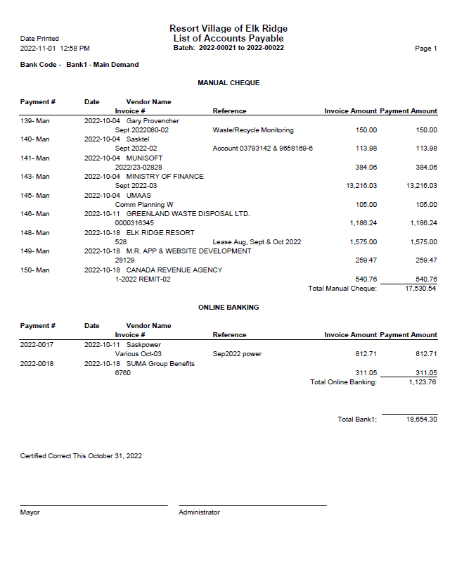
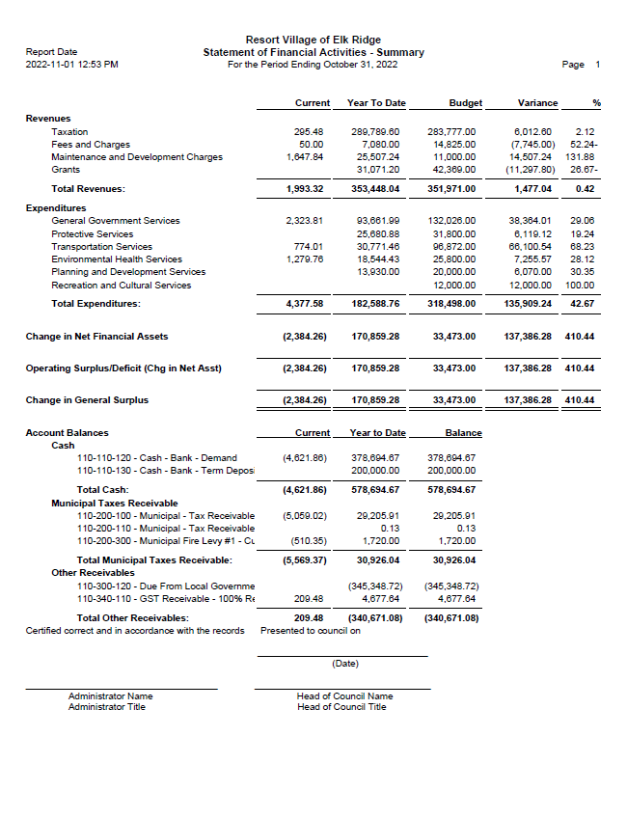

RESORT VILLAGE OF ELK RIDGE
Bank Reconciliation October 2022

GL 110-110-120 – General Ledger Account $378,694.67
- Bank Fees -39.50
- Easypay GL Posting -4,443.77

Adjusted General Ledge Balance: $374,211.40

Bank Account Balance at October 31, 2022 $373,006.98
- Outstanding Cheques -2706.23
- Bank Deposit – 3910.65

Adjusted Bank Balance $374,211.40

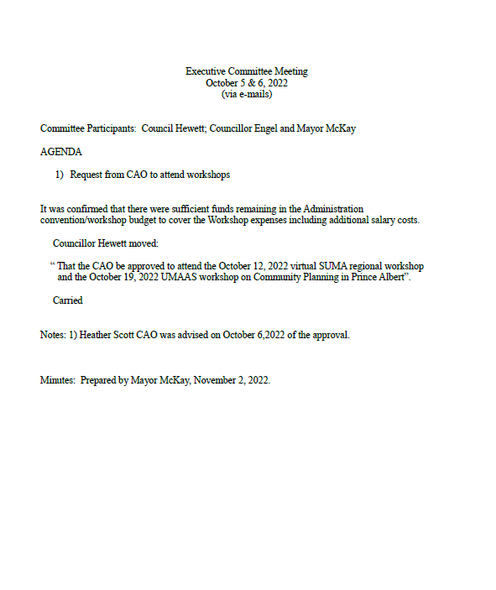

North Central Lakelands Planning District Official Community Plan Update
Next Steps in Engagement

Official Launch of Public Engagement

1. Upload project webpage and provide link to member municipalities.
  - 2. Receive ‘approval to proceed’ from each member municipal council.
  - o Video
  - o Draft survey

  - 3. Finalize digital posterboards for project webpage drawn from video.
  - 4. Finalize survey.
  - o Create online version
  - o Send digital copy to regional partners who might provide print copies.

  - 5. Prepare draft news releases including quotes from member municipalities.
  - 6. Coordinate circulation of news releases and social media posts.
  - 7. Prepare regular updates for Vacationland News, The Wave and any other regional newsletters identified.
  - 8. Post regular updates to the project webpage.

Stakeholder Interviews and Data Gathering
1. Continue to gather stakeholder contact information (particularly for major property owners).
2. Email and telephone contact with identified stakeholders through the month of November to request interviews on topics from the survey.
3. Work with municipal Administrators and provincial agencies to complete the background research on planning and economy.
4. Continue to work on base mapping (Crosby Hanna & Associates-led).

Prepare for Phase 2
1. Monitor and promote Survey #1 and project webpage.
2. Prepare interim engagement results report to inform crafting of OCP policies and advice for Zoning Bylaw updates.
  - 3. Prepare draft questions for Survey #2, including some targeted to member municipalities. a. Accommodating seasonal and irregular residents (e.g. RV parks, Airbnb, etc.)
  - b. Missing services and businesses
  - c. Policy map-related questions

