Resort Village of Elk Ridge
May 16th, 2023 at 3:00 p.m. – Regular Meeting – Elk Ridge Resort

- Call to Order – The Mayor called the meeting of Council to order.
- Approval of Agenda:
MOTION: That the agenda for this meeting be approved as presented.
- Adoption of Minutes:
3.1 Page 3 – Minutes of the April 18, 2023 Special Meeting.
MOTION: That the Minutes of the April 18, 2023 Special Meeting be approved as presented.

- Declaration of Conflict of Interest: None
- Delegations Scheduled: None
- Public Hearings:
- Public Acknowledgements:
- Business Arising from Minutes:
Page 7 - SMITH-WINDSOR: That the stipend paid to the Waste Management Site Manager be increased to $175/month beginning May 1st, 2023 in response to the increasing demands of the service.

Page 11 - SMITH-WINDSOR: That the Public Works Committee enter into negotiations with Routes2Sk to purchase the land that situates the Resort Village’s Waste Management Depot on Elk Ridge Place.

Page 12 - SMITH-WINDSOR: It is recommended that the Administrator pursue costs and availability of a qualified engineer to assess the condition of and price estimates for the maintenance/repair of the Resort Village’s municipal roads.

Page 13 - SMITH-WINDSOR: That the Resort Village contributes $12,000 per year to the outdoor recreation activities currently funded entirely by Routes2Sk. The terms of the agreement will be specified in a Memorandum of Understanding between the Resort Village and Routes2Sk.
- New Business:
9.1 Page 14 – Community BBQ/Public Engagement Date
- Motions:
- Administration Reports:
  - Page 15-CAO Report and Updates
- Financial Reports:
12.1 Page 16– Financial Statement for April 2023 and List of Accounts Payable for April 2023.
MOTION: That Council receive and file the financial statement and list of accounts payable for April, 2023.
- Reading of Bylaw(s):
- Notice of Motion:
- Inquiries:
- In camera:
- Information Items/Correspondence:
17.1 Page 18– Public Works Committee – Updated Terms of Reference and Winter Road Maintenance Policy.
17.2 Page 21– Tax Notice Mailout
17.3 Page 23 - Email from Wendy Gowda Re: Reconciliation and CCBF Funding
- Adjournment

Resort Village of Elk Ridge
Meeting Minutes
April 18th, 2023 at 3:00 p.m. – Regular Council Meeting -Elk Ridge Resort

A Meeting of Council of the Resort Village of Elk Ridge was held at the Elk Ridge Golf Resort on April 18th, 2023.

Present: Mayor Garry McKay
Councillor Danberg
Councillor Trudy Engel
Councillor Ross Hewett (via Teams Meeting)
Councillor Margaret Smith-Windsor

Heather Scott, CAO

- Call to Order – The Mayor called the meeting of Council to order at 3:21 p.m.

- Approval of Agenda:
124-2023 DANBERG: Addition: Bylaw 02 – 2023 be added to 13.2 for third reading
SECONDED: ENGEL CARRIED
125-2023 ENGEL: That the agenda for this meeting be approved as amended.
SECONDED: SMITH-WINDSOR CARRIED
- Adoption of Minutes:
3.1 Minutes of the March 21, 2023 Special Meeting.
126-2023 DANBERG: That the Minutes of the March 21st, 2023 Special Meeting be approved as presented.
SECONDED: ENGEL CARRIED
3.2 Minutes of the March 21, 2023 Regular Meeting.
127-2023 HEWETT: That the Minutes of the March 21st, 2023 Regular Meeting be approved as presented.
SECONDED: ENGEL CARRIED
3.3 Minutes of the March 29, 2023 Special Meeting.
128-2023 HEWETT: That the Minutes of the March 29, 2023 Special Meeting be approved as presented.
SECONDED: DANBERG CARRIED
3.4 Minutes of the April 4, 2023 Special Meeting.
129-2023 ENGEL: That the Minutes of the April 4, 2023 Special Meeting be approved as presented.
SECONDED: DANBERG CARRIED

- Declaration of Conflict of Interest: None
- Delegations Scheduled: Joint Utility Committee Report – Clint Austin
130-2023 ENGEL: That the Resort Village of Elk Ridge agrees, in principle to the dissolution of the Elk Ridge Utility Ltd and the amalgamation of its operations, assets and property under the Resort Village of Elk Ridge with the aim of establishing a public utility pursuant to the Municipalities Act.
SECONDED: DANBERG CARRIED
- Public Hearings:
- Public Acknowledgements:
- Business Arising from Minutes: None
- New Business:
9.1 – NCLDPC Alternate
131-2023 DANBERG: that Councillor Smith-Windsor be appointed as alternate to the North Lakeland District Planning Commission.
SECONDED: ENGEL CARRIED
- Motions:
- Administration Reports:
  - CAO Report and Updates
132-2023 ENGEL: That the CAO report for April be received and filed.
SECONDED: DANBERG CARRIED
- Financial Reports:
12.1 Financial Statement for March 2023 and List of Accounts Payable for March 2023.
MOTION: That Council receive and file the financial statement and list of accounts payable for March, 2023.
133-2023 ENGEL: That the detailed financial report be sent to council monthly with the regular agenda.
SECONDED: HEWETT CARRIED
134-2023 ENGEL: Receive and file the March financial statement after specified corrections made and that the accounts payable for March be approved.
SECONDED: SMITH-WINDSOR CARRIED
- Reading of Bylaw(s):
13.1 Bylaw 05 of 2023 a Bylaw to set the Base Tax for the year 2023.
135-2023 SMITH-WINDSOR: That Bylaw 05 of 2023, a Bylaw to set the 2023 Base Tax be introduced and read a first time.
SECONDED: HEWETT CARRIED
136-2023 HEWETT: That Bylaw 05 of 2023, a Bylaw to set the 2023 Base Tax be read a second time.
SECONDED: DANBERG CARRIED
137-2023 DANBERG: That leave be granted for third reading of Bylaw 05 of 2023, a Bylaw to set the 2023 Base Tax.
SECONDED: ENGEL UNANIMOUSLY CARRIED
138-2023 DANBERG: That Bylaw 05 of 2023, a Bylaw to set the 2023 Base Tax be read a third time and adopted.
SECONDED: ENGEL CARRIED
13.2 Bylaw 06 of 2023, a Bylaw to set the 2023 Mill Rates
139-2023 ENGEL: That Bylaw 06 of 2023, a Bylaw to set the 2023 Mill Rates be introduced and read a first time.
SECONDED: SMITH-WINDSOR CARRIED
140-2023 HEWETT: That Bylaw 06 of 2023, a Bylaw to set the 2023 Mill Rates be read a second time.
SECONDED: SMITH-WINDSOR CARRIED

141-2023 DANBERG: That leave be granted for third reading of Bylaw 06 of 2023, a Bylaw to set the 2023 Mill Rates.
SECONDED: ENGEL UNANIMOUSLY CARRIED
142-2023 SMITH-WINDSOR: That Bylaw 06 of 2023, a Bylaw to set the 2023 Mill Rates be read a third time and adopted.
SECONDED: ENGEL CARRIED
  - Bylaw 02 of 2023 Sanitation levy
143-2023 SMITH-WINDSOR: That Bylaw 02 of 2023, a Bylaw to set the 2023 sanitation levy be read a third time and adopted.
SECONDED: DANBERG CARRIED
- Notice of Motion:

SMITH-WINDSOR: That the stipend paid to the Waste Management Site Manager be increased to $175/month beginning May 1st, 2023 in response to the increasing demands of the service.

SMITH-WINDSOR: That the Public Works Committee enter into negotiations with Routes2Sk to purchase the land that situates the Resort Village’s Waste Management Depot on Elk Ridge Place.

SMITH-WINDSOR: It is recommended that the Administrator pursue costs and availability of a qualified engineer to assess the condition of and price estimates for the maintenance/repair of the Resort Village’s municipal roads.

SMITH-WINDSOR: That the Resort Village contributes $12,000 per year to the outdoor recreation activities currently funded entirely by Routes2Sk. The terms of the agreement will be specified in a Memorandum of Understanding between the Resort Village and Routes2Sk.
- Inquiries:
- In camera:
- Information Items/Correspondence:
17.1 – Joint Utility Committee Update
- Adjournment
144-2023 DANBERG: That the meeting adjourn at 5:14 p.m.
SECONDED: SMITH-WINDSOR CARRIED

_____________________________ ___________________________
Mayor CAO

DECISION ITEM

Subject | Waste Management Increase Request
Council Meeting Date Presented: | May 16, 2023
Agenda Item: | 8.1
Prepared By: | Heather Scott CAO

- A notice of motion was brough forward at the April 18, 2023 Council meeting which read:
SMITH-WINDSOR: That the stipend paid to the Waste Management Site Manager be increased to $175/month beginning May 1st, 2023 in response to the increasing demands of the service.

- The staff housing unit is now being levied for sanitation service as well as 58 new RV sites. Based on this, there were concerns that there would be a requirement for increased monitoring of the waste management site.
- The following was received from Gary Provencher who currently holds the contract for monitoring the area:

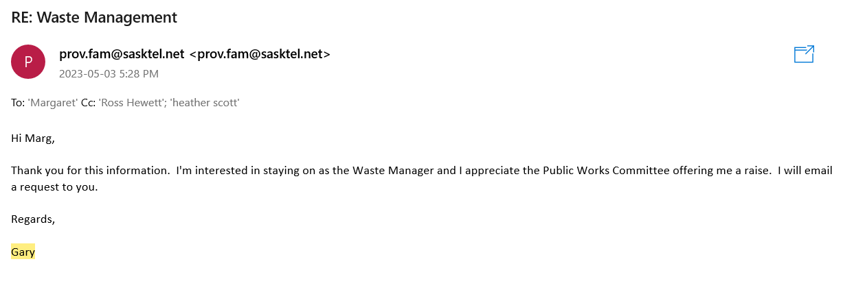
- There is a current agreement for service between the municipality and Gary Provencher where he currently is paid $150/month for monitoring the waste management area.

BUDGET & OTHER CONSIDERATIONS:
- 540-440-100 Waste Management Supervision - $1400 from May – December 2023. (an increase of 200)

RECOMMENDATION:
- This information is provided for council’s information when taking into consideration the motion for the increase.

PROPOSED MOTIONS:

Respectfully Submitted by: Heather Scott, CAO

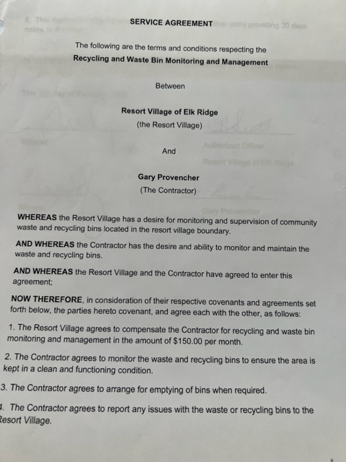
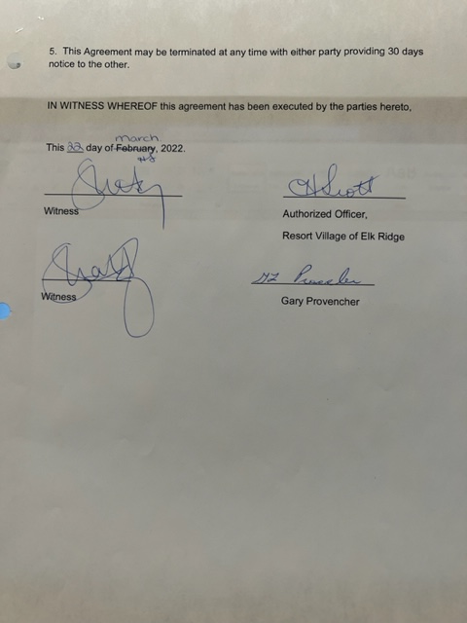
DECISION ITEM

Subject | Waste Management Depot Land
Council Meeting Date Presented: | May 16, 2023
Agenda Item: | 8.2
Prepared By: | Heather Scott CAO

BACKGROUND:
- At the April 18, 2023 Council meeting, the following Notice of Motion was brought forward:
SMITH-WINDSOR: That the Public Works Committee enter into negotiations with Routes2Sk to purchase the land that situates the Resort Village’s Waste Management Depot on Elk Ridge Place.
- The waste management and recycling bins are leased by the Resort Village of Elk Ridge yet the land they sit on is owned by Elk Ridge Resort.
- There are several options to look at as to whether the municipality wants to enter into a land use agreement with the Resort, a lease or purchase.
- The motion provides for the Public Works Committee to meet with the Resort and bring back recommendations to Council based on those discussions.
BUDGET & OTHER CONSIDERATIONS:
- N/A

RECOMMENDATION:
- That Council consider granting the Public Works Committee to call a meeting and invite Routes2SK representatives to have a discussion on land use for the Waste Management Depot.
- Administration recommends amending the motion to read:
- That the Public Works Committee enter into negotiations with Routes2Sk for use of the land that situates the Resort Village’s Waste Management Depot on Elk Ridge Place.

Respectfully Submitted by: Heather Scott, CAO

DECISION ITEM

Subject | Public Road Assessment
Council Meeting Date Presented: | May 16, 2023
Agenda Item: | 8.2
Prepared By: | Heather Scott CAO

BACKGROUND:
- At the April 18, 2023 Council meeting, the following Notice of Motion was brought forward:
SMITH-WINDSOR: It is recommended that the Administrator pursue costs and availability of a qualified engineer to assess the condition of and price estimates for the maintenance/repair of the Resort Village’s municipal roads.
- There is some alligator cracking and break down of pavement of the access road into the Resort.
- Typically, a recommendation of this type would be discussed at a committee level first and then a recommendation brought forward from those Minutes; however, there is reference to this on the Public Works Committee Terms of Reference.
- Council also has an Engineering firm under contract with the Resort Village of Elk Ridge so an alternative would be to reach out to them to inspection the road and bring recommendations back. Their cost to conduct the inspection would be approximately $3500. This assessment and report would include a visual on-site inspection, potential rehabilitation recommendations and budget for rehabilitation.
- Associated Engineering is quite often in the area and it is likely would be able to provide an assessment in a timely manner.
BUDGET & OTHER CONSIDERATIONS:
- $3,500 for inspection and reporting of findings and recommendation for rehabilitation.

RECOMMENDATION/PROPOSED MOTION:
- That Council direct administration to contact Associated Engineering to conduct a road assessment as soon as possible and bring back recommendations to the Public Works Committee to evaluate and make recommendations to Council at a future meeting.

Respectfully Submitted by: Heather Scott, CAO

DECISION ITEM

Subject | Outdoor Recreation Activities
Council Meeting Date Presented: | May 16, 2023
Agenda Item: | 8.2
Prepared By: | Heather Scott CAO

BACKGROUND:
- At the April 18, 2023 Council meeting, the following Notice of Motion was brought forward:

- SMITH-WINDSOR: That the Resort Village contributes $12,000 per year to the outdoor recreation activities currently funded entirely by Routes2Sk. The terms of the agreement will be specified in a Memorandum of Understanding between the Resort Village and Routes2Sk.

- The Resort offers several outdoor recreation activities each year. Some of these events charge an admittance fee and some are free to the public.
- It is unsure how many of these activities may receive funding from other sources such as donations or grant funding.
- There’s no doubt that Routes2SK provides the majority of recreation and outdoor activities throughout the year, but there may also be some other groups that provide or wish to provide activities that would also benefit from funding.
- As a municipality, Sask Lotteries has also provided grant funding in the amount of $975 to be provided to the community for Sport, Culture and Recreation programs.
BUDGET & OTHER CONSIDERATIONS:
- $12,000 from GL 570-290-200 Community Recreation Initiative.

RECOMMENDATION:
- That Council reach out to the Resort and community to advise that there is some funding available to assist with community events and recreation activities as there may be other groups that could benefit from funding. This would give Council and the public a better idea of where best to utilize these funds and provide transparency and accountability as to where exactly these funds are being used.
- Any responses could be vetted by the Community Services Committee with recommendations for allocation being brought back to Council for review.

PROPOSED MOTION:
- That Council direct administration to advertise that there is public funding available for sport, culture and recreation events in the community and provide any requests to the Community Services Committee for review and recommendations.

Respectfully Submitted by: Heather Scott, CAO
DECISION ITEM

Subject | Community BBQ/ Public Engagement Date
Council Meeting Date Presented: | May 16, 2023
Agenda Item: | 9.1
Prepared By: | Heather Scott CAO

- Council hosted a community BBQ in 2022 and indicated its interest in this becoming an annual event.
- Jim Walters from Crosby Hannah would like to coordinate their Community Plan public engagement with the community BBQ.
- Jim Walters reached out to administration May 10th asking if a date has been set yet for the community BBQ as they would like to include the date in some advertising that they are publishing.

BUDGET & OTHER CONSIDERATIONS:

- Cost of event for food costs

RECOMMENDATION:
- That Council set the community BBQ date to allow for Crosby Hannah to schedule the public engagement at the same time.
- Possible dates for June that work with what the Resort has booked would be June 26, 27 or 30.
- The only scheduling issue might be with the council meeting June 27th so it’s recommended Council schedule the BBQ on either Monday, June 26th or Friday June 30, 2023.

PROPOSED MOTIONS:
- That Council set the Community BBQ and Crosby Hannah public engagement for June ____, 2023.

Respectfully Submitted by: Heather Scott, CAO

ADMINISTRATOR'S REPORT : MAY 2023
Date | ADMINISTRATION HIGHLIGHTS: | Target
2023-05-11 | There are 0 new building permits so far this year and 10 ongoing. There are three pending permits, one for landscaping, one for a deck and the other for a new residence. | ongoing
2023-12-15 | Followed up with Auditor The CAO has been working on providing requested documents to the auditor prior to them attending in the community. | Apr-23
2023-05-11 | Update from Wendy Gowda. She has now drafted a reconciliation document and submitted it to Government Relations for review and response. There remains one issue outstanding with respect to the CCFB funding. | 31-Dec-22
Date | MISCELLANOUS | Target
2023-06-06 | The CAO has registed for the UMAAS Convention June 6-9, 2023. It is important for the CAO to attend various training and ongoing educational requirements in order to meet certification requirements. | 09-Jun-23
 |  | Target
Date | MINUTES FOLLOW UP | Target
2023-04-27 | The North Central Lakeland District Planning Commission has been advised that Councillor Smith-Windsor will be the alternate member to attend in the event the Mayor is unable to attend. | complete
Date | COMMITTEES | Target
2022-01-09 | Updated Public Works Committee Action Plan included on the May agenda. | ongoing
2023-02-02 | EMO Committee terms of reference updated and new members appointed at January meeting. | ongoing
Date | HIGHWAYS | Target
2023-03-15 | Highway signs should be on workplan for 2023 | ongoing
Date | GRANT UPDATES/UPCOMING | Target
2023-02-14 | Crosby Hanna applied for the second intake for the TSS Targeted Sector Initiative Grant for their work associated with the planning partners zoning and development bylaws. This grant covers 75% of eligible costs leaving municipalities with 25%. | application successful
2022-02-14 | Funding received for continued work of Wallace Insights and Jim Walters on new planning bylaw development. Awaiting public engagement and consultation. | 2023 bylaw completion.
Date | LEGISLATIVE REQUIREMENTS | Target
2023-05-15 | To date there have been no assessment appeals. The assessment roll closes on May 15th, 2023 with the tax notices being prepared for mailout May 16, 2023. | 15-May-23
Date | PUBLIC WORKS | Target
2023-05-18 | The large spring clean up waste container will be delivered to be in place over the long weekend. Council and the Resort employees have been advised. Administration will prepare a public notice. | 18-May-23
Date | BYLAWS/POLICIES | Target
2022-10-01 | Zoning and DOCP - Crosby Hannah engaged to redraft | 31-Dec-23
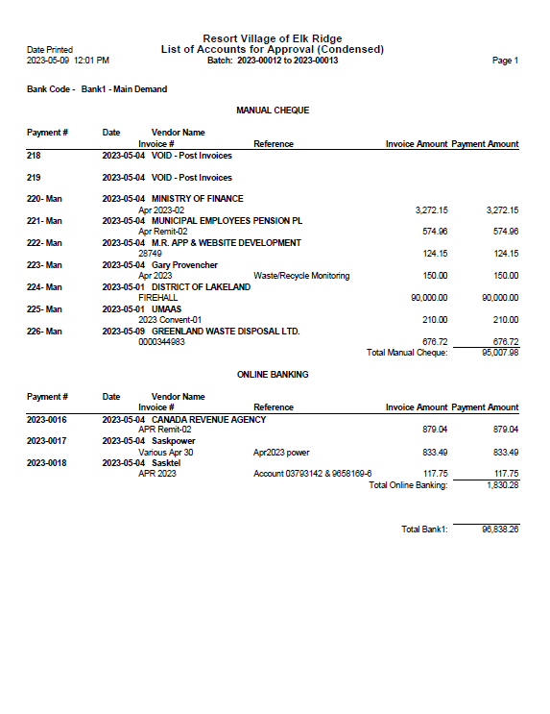
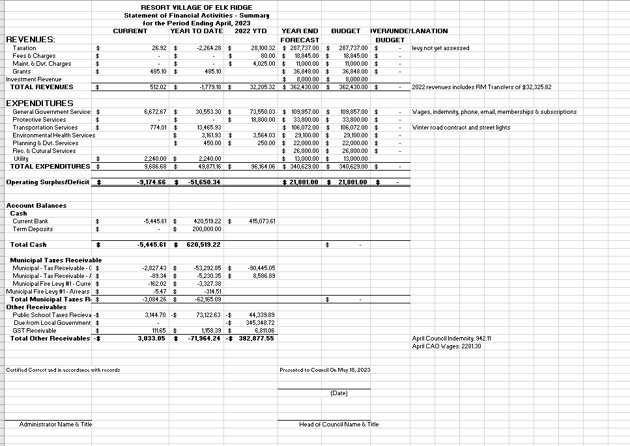



PUBLIC WORKS COMMITTEE
TERMS OF REFERENCE

PURPOSE:
To provide support and direction to the CAO on Public Works matters within the Resort Village of Elk Ridge.

GOVERNANCE:
The Committee is responsible to Council.

SCOPE:
Public Works areas of interest:
- Municipal Roads;
- Waste Management;
- Physical Addressing;
- Water and Sewage;
- Street Lighting;
- Aurora Huts;
- Drainage; and
- Land Acquisition.

MEMBERS:
1. Marg Smith-Windsor, Chairperson
2. Ross Hewett
3. CAO, Advisor

FUNCTION:
To provide support and direction to the CAO on matters dealing with Public Works and oversee public works projects and work in the absence of the CAO.

MEETINGS:
As required

ACTION PLAN:

Priority | Area | Action | Lead | Target
A | Roads – Snow Removal | - Update winter road maintenance policy – check with contractor re: marker placements  - Distribute revised policy to condo corps and contractor  - Tender for gravel clean-up (retain gravel – where?) | CAO | May
A | Waste Management | - Order roll off bin, spring and fall  - Another bin???  - Gary P. to write letter requesting X$ increase  - Inform contractor 72 additional units to depot  - Compost?? | CAO | May
A | Land Acquisition | - Submit Waste Management Depot Motion | MSR | May
A | Roads – Pavement Repairs | - Engineer’s evaluation of municipal roads  - Identify repair areas and priorities  - Recommend NOT repainting lines this year  - Signage? | PW | Aug
B | Addressing – Postal Code & Boxes | - Follow-up with Canada Post to ensure on 2024 work plan | CAO | July
C | Lighting | - LED upgrading  - Dark Sky?? | CAO | July

Resort Village of Elk Ridge Winter Road Maintenance Policy

The policy covers Arne Petersen Way, Elk Ridge Place to the former Firehall and TreeOsix and the internal roads within the participating condominium corporations. The refuse depot site will also be cleared.
- The goal is to maintain a 2-3 inch snowpack on condominium roads and a minimal snowpack on municipal roads (particularly at the entrance).
- Clearing is restricted to the pavement only.
- To avoid damage, in the fall, property owners and Routes2Sk need to mark the edge of the pavement, along their property lines.
- In the event of a major snowfall, a “passage plow” will be the initiated. Clearing of remaining roads and windrows will be undertaken after ALL roads are accessible.
- Snow shall be pushed from the roadway onto Condominium common areas, front yards and adjacent to the municipal roads.
- Driveway access to the paved roadways shall not be blocked by windrows in excess of approximately 15 cms. (6 inches).
- Driveways, utility boxes and fire hydrants will be marked by the condo corps and snow shall not be dumped on them. Natural snow accumulation around utility boxes and hydrants is not the responsibility of the contractor.
- Owners will not deposit snow from their property onto the roads or commons.
- Guest parking, private sidewalk and driveway clearing are the responsibility of the applicable owners.
- Snow hauling or removal is not the responsibility of the Resort Village or its contractor.
- Sanding shall be undertaken where slippery or icy conditions exist.

Note: Condo Corps and/or the contractor shall contact the following regarding the interpretation of this Policy as required.

Heather Scott Marg Smith-Windsor Ross Hewett
306-306-940-9052 306-663-5744 780-777-4962
infoelkridge@sasktel.net smithwindsor@sasktel.net ross.hewett@sasktel.net

Policy approved



PROPOSED STRUCTURAL AND OWNERSHIP CHANGES
TO ELK RIDGE
WATER UTILITY

At Council’s meeting on April 18th, 2023, a motion was unanimously agreed,
“in principle”, to the dissolution of Elk Ridge Utility Ltd., as a non-profit corporation, under the Non-Profit Act, and to the amalgamation of its operations, assets and property under the Resort Village of Elk Ridge. The aim is to establish a public utility pursuant to the Saskatchewan Municipalities Act.

A joint committee has been exploring the feasibility of this amalgamation and with the assistance of legal opinion, has concluded it strongly supports the amalgamation for the following reasons:
1. Enables council to fulfill its responsibility for ensuring that there is a supply of potable water and a system for the disposal of sewage for the inhabitants of the Resort Village and is the standard model for delivering water and sewer services in the province of Saskatchewan;
2. Elk Ridge Utility faces significant capital renewal costs in the next five to ten years. A public utility has a broader set of financing options than a non-profit corporation and has a higher likelihood of success when submitting grant applications. There are also several cost and process synergies that can be realized by amalgaming different public services under one entity. Projects
3. Increases ability to retain and attract a talented workforce;
4. Reduces burden on a ten-person volunteer utility board;
5. Brings simplicity, clarity and alignment to the operation and delivery of public works services.

It is important to recognize that the matter is still in the “feasibility” stage as there are many elements of due diligence and planning to consider. A plan for engaging utility stakeholders and Resort Village constituents in this initiative has been developed and is currently underway.
Council would like to hear from its constituents on the matter and invites you to attend a Town Hall Meeting on June 27th 2023. Any immediate feedback on this initiative can be forwarded to infoelkridge@sasktel.net.

Council Contact Information:

Mayor Garry McKay – 306-690-1482 Councillor Ryan Danberg – 306-981-3822
Councillor Trudy Engel – 306-220-2707 Councillor Ross Hewett – 780-777-4962
Councillor Margaret Smith-Windsor – 306-940-7058

2023 Tax and Budget Information

Council approved the 2023 Budget at their meeting held April 4, 2023. In accordance with the 2023 Budget, the Resort Village of Elk Ridge Council set the 2023 mill rate at 2.77 for all property classes, the base tax on unimproved properties was set at $100 and the base tax on improved properties was set at $200. These rates remain unchanged from 2022 which reflects that there was no tax increase from last year’s rates.
Some other items of note from the 2023 Budget:
- $50,000 has been allocated to the public works reserve.
- $10,000 has been allocated to the recreation reserve.
- Council has come to an agreement with the District of Lakeland for the purchase or the former firehall building and land.

Tax payments can be made:
- Via online etransfer to infoelkridge@sasktel.net
- By cheque or cash in person at the municipal office located next to The Wyld at 211 Arne Petersen Way; or
- By post mail to the address below.

Resort Village of Elk Ridge
Box 171
WASKESIU LAKE, SK S0J 2Y0
Telephone No. (306) 940-9052
Email Address: infoelkridge@sasktel.net
Administrator: Heather Scott

Rules regarding Fire Pits pursuant to municipal Bylaw 27 of 2022:
- Open-air fires are not permitted outside the hours of 2:00 p.m. to 11:00 p.m.
- Open air fires are permitted only when the wind does not exceed 15 kmh.
- Unless the ground is snow covered any open-air fire/solid fuel fire shall:
    - burn only dry, seasoned, preservative-free cord wood or charcoal briquettes.
    - be in a non-combustible receptacle made of materials such as brick, cement or metal of at least 18 gauge and on a non-combustible base;
    - not be closer than 3 m. (9.84 feet) to the unit’s property line and no closer than 3 m. (9.84 feet) to any combustibles. Distance from combustibles to be measured from the edge of any overhangs.
    - not contain, rubbish, household/garden/yard waste, or building materials, plastics, rubber, painted or creosoted wood or any contraventions of the Air Quality Pollution Control Act of the Province of Saskatchewan.
    - the opening of the firebox cannot exceed .61 m. or 24 inches.
    - be covered with a heavy gauge spark arrester screen.
    - not have a flame more than ½ m. or 18 inches above the wall of the receptacle.
    - be supervised continuously by an adult with a nearby means of extinguishing the fire such as a fire extinguisher, a water hose;
    - be thoroughly extinguished before leaving an open-air fire.

-------- Original Message --------
Subject: Fwd: CCBF Correspondence relating to the municipal restructuring of Elk Ridge
Date: Thu, 27 Apr 2023 10:26:11 -0400
From: wgowda@sasktel.net
To: infoelkridge@sasktel.net
Cc: tracey.m@lakeland521.ca
Good Morning Heather,
Further to our telephone discussion earlier this week, please refer to the attached email and letter from Cathy Moberly. I have followed up with a telephone call to Cathy and Judy Kanak, and understand that the RV and RM can negotiate an agreement to the CCBF amount settlement, if any, to be paid from the RM to the RV as part of the settling of assets and liabilities.
There is a link to the schedule of allocations and advancements by year, included in the email; and in our telephone discussion, using a population of 132 (Revenue Sharing allocation for the hamlet) $21,290 was calculated based on the per/capita funding either allocated or advanced to the RM, for the time the RV was incorporated, prior to a new agreement being entered into.
My understanding is that a lump-sum settlement would be preferred to a pro-rata distribution based on the CCBF payments, as while this funding is allocated, it has not all been advanced, and the implications would affect future year's financial reporting.
I will be available to meet with yourself and/or representatives of the board, if you have additional questions or if I can provide additional information, or assist in any way. This is the final outstanding item for the settling of assets and liabilities, for which we are all anxious to be finalized.
While copying Tracey, I am requesting the RV, initially to determine a position, to present to the RM for consideration. Thanks for your consideration.
Wendy Gowda
-------- Original Message --------
Subject: CCBF Correspondence relating to the municipal restructuring of Elk Ridge
Date: Wed, 12 Apr 2023 20:10:01 +0000
From: "Bereti, Lisa GR" <lisa.bereti@gov.sk.ca>
To: "wgowda@sasktel.net" <wgowda@sasktel.net>
Cc: "Moberly, Cathy GR" <cathy.moberly@gov.sk.ca>, "Kanak, Judy GR" <judy.kanak@gov.sk.ca>
Hi Wendy,
Attached is correspondence relating to the municipal restructuring of Resort Village of Elk Ridge and the federal Canada Community-Building Fund (CCBF) program administered by the provincial government in Saskatchewan. Once the document is signed and returned, we will transfer the previously withheld payments to the RM. Our goal is to have this completed by the end of April 2023.
We also provide a link to our webpage, which includes the annual CCBF allocations for each municipality, the 2016 Census population used for the calculation, and the annual per capita amount. This information may assist you when you are determining the portion of the installments to allocate to the RV in the settlement. Link: Canada Community-Building Fund | Canada Community-Building Fund Program | Government of Saskatchewan, Section 1, under Related Items.

Please let us know if you have any questions or if we can provide further information.
Thanks for your patience,
Lisa

Lisa Bereti
Government of Saskatchewan
Senior Program and Policy Analyst, Canada Community-Building Fund and Financial Management
Municipal Infrastructure and Finance, Ministry of Government Relations

500 – 1855 Victoria Avenue
Regina, Canada S4P 3T2
Tel 306-787-4607
lisa.bereti@gov.sk.ca

